Year 5 Curriculum Overview 2023-24
Subject | Advent 1 | Advent 2 | Lent 1 | Lent 2 | Pentecost 1 | Pentecost 2
RE | Domestic Church  Ourselves - Created in the image and likeness of God  5th Sep – 29th Sep  Judaism Passover  2nd Oct – 20th Oct | Baptism/Confirmation  LIFE CHOICES - Marriage, commitment and service  6th Nov – 1st Nov  Advent/Christmas  hope - Advent: waiting in the joyful hope for Jesus, the promised one  4th – 20th Dec | Local Church  mission - Continuing Jesus’ mission in diocese (ecumenism)  3rd Jan – 2nd Feb  Eucharist  memorial Sacrifice - Eucharist as the living memorial of Christ’s sacrifice  5th February – 5th March | Lent/Easter  sacrifice - Lent: a time of aligning with the sacrifice made by Jesus  6th March–28th March | Pentecost  TRANSFORMATION - Celebration of the Spirit’s transforming power  15th April – 10th May  Hinduism Belief in one God  13th - 24th May | Reconciliation/Anointing of the sick  FREEDOM & RESPONSIBILITY -Commandments enable Christians to be free & responsible  3rd June–25th June  Universal Church  STEWARDSHIP - The Church is called to the stewardship of Creation  26th June–19th July
English  Writing | 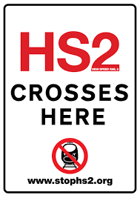  Writing to discuss  Writing to entertain | 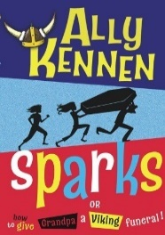  Writing to entertain  Writing to persuade | 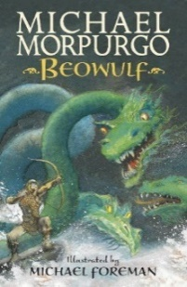  Writing to inform  Writing to entertain | Winter Olympics 2014: Trailer - BBC Sport  Writing to entertain  Writing to inform | 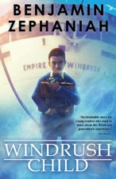  Writing to inform  Writing to entertain | 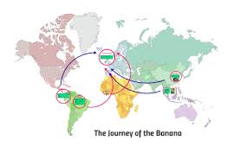  Writing to persuade  Writing to inform
English Grammar | Recap of previous objectives | Cohesion within paragraphs  Adverbials | Relative clauses  Parenthesis (dashes, brackets and commas) | Commas to clarify meaning  Tenses  Noun/adjective suffixes | Adverbs (degrees of possibility)  Verb prefixes | Consolidation
English Spelling | -ible / -able | ie / ei  silent letters  homophones  -ant /- ent  -ence / -ance | ough  hyphen  etymology  prefixes  homophones | ably / ibly  prefix  di, dis or de  le, il, el, al  tricky spelling | homophones/near homophones  common exception x 3 | ch  root words  ph  ent
Maths | Place Value  Addition and Subtraction | Multiplication and Division  Fractions | Multiplication and Division  Fractions  Decimals and Percentages | Decimals and Percentages  Perimeter and Area  Statistics | Shape  Position and Direction  Decimals | Decimals  Negative Numbers  Converting Units  Volume
Science | Life Cycles | Materials | Space | Forces | Materials-Changes | Key Scientists
Humanities | Geography:  Local Environment | History:  Vikings | History:  Anglo-Saxons | Geography:  Europe – The Alps | History:  Journeys- why do people go on journeys? | Geography:  Journeys- Trade
Art / DT | Topic: Local environment  Area of Art: Drawing & Sketching  Outcome: Drawing of a local street  Henri Rousseau  (Post Impressionism) | Area of Art: Drawing & Digital Media  Outcome: Digital drawing of arctic landscape  Artist: Edward Wilson  (scientific artist) | Topic: Space  Area of DT: Mechanisms  Final Product: Space pop-up book  Create a functional four-page pop-up storybook design, using lever, sliders, layers and spacers to create paper-based mechanisms. | Topic: Mountains  Area of DT:  Digital World  Final Product: Monitoring devices  Apply Computing knowledge and understanding to program a Micro: bit animal monitoring device. Develop 3D CAD skills by learning how to navigate the Tinkercad interface and essential tools to combine multiple objects. | Topic: Journeys  Area of DT: Structures  Final Product: Bridges  Test and analysis of various types of bridges to determine their strength and stability. Explore material properties and sources, before marking, sawing and assembling a wooden truss bridge. | Area of Art: Drawing & 3D  Outcome: Clay busts of scientists  Artist: Classical and ancient sculptures.  (Pre- Classical / Archaic)
Computing | Sharing Information | Video editing | Selection in physical computing | Flat -file databases | Vector Drawing | Selection in quizzes
Music | Drumming | Drumming | Drumming | Drumming | Drumming | Drumming
Spanish | Los Instrumentos  (Musical instruments) | La Familia  (the family) | Mi Clase  (In the classroom) | Qué Fecha Es Hoy?  (What is the date?) | La Ropa  (Clothes) | Recap
PE | Basketball | Dance | Gymnastics | Tag Rugby | Rounders | Athletics
PSHE | Personal Relationships | Valuing differences | Keeping Safe | Living in the Wider World | Me, My Body, My Health  Emotional Well-Being | Life Cycles

