Year 4 Curriculum Overview 2023-24
Subject | Advent 1 | Advent 2 | Lent 1 | Lent 2 | Pentecost 1 | Pentecost 2
RE | Domestic Church  People- The family of God in Scripture  5th Sep – 29th Sep  Judaism  Torah  2nd Oct – 20th Oct | Baptism/Confirmation  Called - Confirmation: a call to witness  6th Nov – 1st Nov  Advent/Christmas  Gift - God’s gift of love and friendship in Jesus  4th – 20th Dec | Local Church  Community- Life in the local Christian community and ministries in the parish  3rd Jan – 2nd Feb  Eucharist  Giving and Receiving-  Living in communion  5th February – 5th March | Eucharist  Giving and Receiving-  Living in communion  5th February – 5th March  Lent/Easter  Self-Discipline- Celebrating growth to new life  6th March–28th | Pentecost  New Life- To hear and live the Easter message  15th April – 10th May  Other Religions  Sikhism -Guru Granth Sahib  13th - 24th May | Reconciliation/  Anointing of the sick  Building Bridges - Admitting wrong, being reconciled with God and each other  3rd June–25th June  Universal Church  God’s People - Different saints show people what God is like  26th June–19th July
English  Writing | 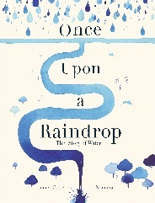  Writing to inform  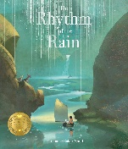  Writing to entertain | Writing to entertain and inform. | 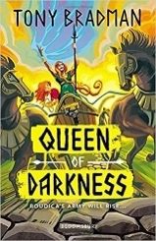  Writing to entertain | 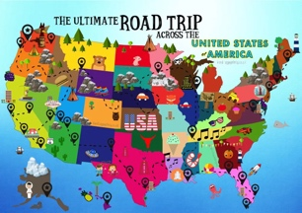  Writing to persuade and inform | Writing to entertain and persuade | 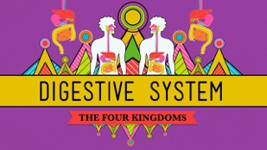  Writing to entertain and inform
English Grammar | Direct speech  Plural + possessive s | Inverted commas  Fronted adverbials | Conjunctions  Expanded noun phrases | Commas to mark clauses  Imperative verbs | Emotive language  Sentence openers | Embedded clauses  Linkage of Paragraphs
English Spelling | Homophones  eI- long a sound  sc- silent c  que/gue  ch- makes sh sound  ch- makes the k sound | i or y  -ure  -sion = shun  Suffix -ous  Prefixes | Root words and suffixes  Sound ou = u  Singular plurals  Possession  Prefixes | Homophone  all = l  Suffix -ful  Suffixes  Adding -ous = adjectives | Homophone  Common exception words  Synonyms and Antonyms | Unstressed vowel  Soft g and hard g  augh/au  Compound nouns
Maths | Place value  Addition and Subtraction  Area | Multiplication and Division  Measurement | Multiplication and Division  Fractions  Length and Perimeter | Fractions  Decimals | Decimals  Money  Time | Shape  Statistics  Position and Direction
Science | States of Matter | Key Scientist: Sir Alexander Graham Bell | Electricity | Sound | Living Things and Their Habitats | Animals Including Humans: Teeth, eating, and digestion
Humanities | Geography: Rivers and the Water Cycle | History: Ancient Egyptians | History: Roman Britain | Geography: The Americas | History: Crime and Punishment | Geography: Earthquakes and Volcanoes
Art / DT | Art: Drawing and Collage  Outcome: Water scene collage | DT: Levers and Linkages:  Outcome: Moving Egyptian Scene | Art: Mosaics  Outcome: Mosaic coaster | DT: Electrical Systems  Outcome: Torches | Art: Textiles  Outcome: A garment | DT: Cooking and nutrition:  Outcome: Biscuits
Computing | The Internet | Repetition in Games | Audio Editing | Photo editing | Repetition in Shapes | Data Logging
Music | ABBA | Glockenspiel: Stage 2 | Grime: Lyric Writing | Passion Play Production | Gospel Music:  Lean on Me | Pop: The Beatles
Spanish | Greetings | Animals | Classroom Commands | The Shapes | Regular Verbs | Revision
PSHE | Emotional Well-being | Life Cycles | Personal Relationships | Life Online | Keeping Safe | Living in the Wider World
PE | Swimming |  | Swimming |  | Dance | Athletics

