Year 3 Curriculum Overview 2023-24
Subject | Advent 1 | Advent 2 | Lent 1 | Lent 2 | Pentecost 1 | Pentecost 2
RE | HOMES  God’s vision for every family  Judaism - Synagogue | PROMISES  Promises made at Baptism  VISITORS  Waiting for the coming of Jesus | Journeys  Christian family’s journey with Christ  Sharing Jesus gives himself to us | Lent: remembering Jesus’ total giving | ENERGY - Gifts of the Holy Spirit  Islam  The Mosque | CHOICES  Importance of examination of conscience  SPECIAL PLACES  Holy places for Jesus and the Christian community
English  Writing | Writing to inform  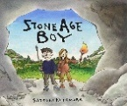  Writing to entertain | 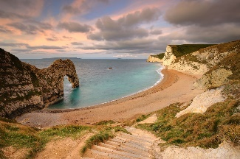  Writing to inform  Writing to persuade | 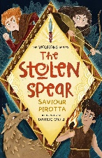  Writing to entertain | Writing to entertain | 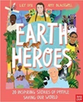  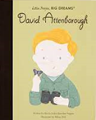  Writing to inform | 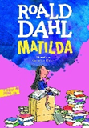  Writing to persuade  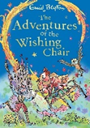  Writing to entertain
English Grammar | •Use the forms a or an according to whether the next word begins with a consonant or a vowel [a rock or an open box]. | •Headings and subheadings to aid presentation.  •Express time, place and cause using conjunctions [when, before, while, after, so, because] and adverbs [then, next, soon, before] and prepositions [before, after, during, in, under]. | •Use of the present perfect form of tense rather than the simple past [he has gone out to play rather than he went out to play].  - Introduction to inverted commas to punctuate speech. | - Understand word families based on common words, showing how words are related in form and meaning [solve, solution, solver, dissolve, soluble]. | •Form nouns using a range of prefixes (super-, anti-, auto-).  •Introduction to paragraphs as a way of grouping related information. | - Create sentences that include subordinate clauses.
English Spelling | Homophones  ‘ei’ words  ‘sc’ words  ‘ch/cr’ words  ‘k’ or ‘ch’ words | ‘I’ or ‘y’ words  ‘ure’  ‘sion’  ‘ous’  prefix: dis/mis  prefix: im/re | suffix – double consonant  ‘ou’  plurals  Year 3-4 spellings  prefix: sub, inter, auto, anti | Homophones  ‘al’  suffix – ful  suffixes  suffix - ous | Homophones  Common exception words | Unstressed vowels  Hard and soft g  ‘augh’ and ‘au’ words  Compound nouns
Maths | Place value  Addition + Subtraction | Addition + Subtraction  Multiplication + Division | Multiplication + Division  Length and Perimeter | Fractions  Mass and Capacity | Fractions  Money  Time | Shape  Statistics  (Consolidation)
Science | Light | Materials and their properties  Rocks | Forces and Magnets | Animals including humans | Plants | Key Scientists
Humanities | History: The Stone Age | Geography: Coasts | History: The Bronze Age and Iron Age | Geography: Climate and Weather | Geography: Our World | History: Local History
Art / DT | Art: Topic – Stone age  Area of Art – Drawing & Painting  Outcome: Painting | DT: Topic: Coasts  Area of DT: Food  Final Product: Make your own ice cream. | DT: Topic: Iron age and Bronze age  Area of DT: Frame Structures  Final Product: Roundhouse | Art: Topic: Climate  Area of Art: Drawing & Printing  Outcome: Block Print  Artist: O’Keeffe  (Contemporary) | Art: Topic: Our world  Area of Art: Drawing & Digital Media  Outcome: Digital Picture  Artist: Bernard Hoyes  (African American art) | DT: Topic: Local History  Area of DT: Textile  Final Product: Cushion  Learn and apply two new sewing techniques
Computing | Connecting computers | Events and actions in programs | Stop -frame animation | Sequencing sounds | Branching Databases | Desktop publishing
Music | Listen and Appraise  To know some songs have a chorus or a response/ answer part  To learn how songs can tell a story or describe an idea.  Performance  To perform in front of an audience as part of KS2 Christmas concert. |  | Playing the recorder  To learn the names of the notes in their instrumental part from memory or when written down.  To learn to play a tuned instrumental part that matched their musical challenge (one-note/ simple/ medium part)  To play the part in time with the steady pulse  To listen carefully to musical instructions and follow instructions from a leader. |  | Playing the recorder  Improvisation and Composition  To understand that improvisation is unique to a person making up your own tunes on the spot as it is not written down.  To understand that composing is like writing a story with music.  To recognise that everyone can improvise and compose.  To improvise using instruments:  To create a simple melody using one, three or five notes.  To learn that the notes of the composition can be written and changed if necessary.
Spanish | Los Números  (Numbers) | Los Días  (Days of the week)  Los Meses  (Months of the Year) | Los Saludos (Greetings) | Yo Aprendo Español (I’m learning Spanish) | Peudo  (I can) | Revision of – I’m learning Spanish, Greetings, days of the week, months of the year, numbers and I can
PE | OAA  Gym | Dance - The Stone Age  Netball | Tag rugby  Gym | Cricket  Tennis | Athletics  Swimming | Swimming  Tennis
PSHE | We Don’t Have to be the Same  Respecting Our Bodies | What am I Feeling?  What am I Looking at? | Family, Friends and Others  When Things Feel Bad | Sharing Online  Chatting Online | A Community of Love  What Is the Church? | How do I love others?  Working Together

