Year 2 Curriculum Overview 2023-24
Subject | Advent 1 | Advent 2 | Lent 1 | Lent 2 | Pentecost 1 | Pentecost 2
RE | Domestic Church  Beginnings  God is present in every beginning  Judaism  Shabbat | Baptism/Confirmation  Signs and Symbols  Signs and symbols in baptism  Advent/Christmas  Preparations  Advent; Preparing to celebrate Christmas | Local Church  Books  Books used in Church | Eucharist  Thanksgiving  Mass, a special time to thank God  Lent/Easter  Opportunities  Lent; opportunity to start new | Pentecost  Spread the word  Pentecost; a time to spread the Good News  Hinduism  Prayer at home/ Puja | Reconciliation/  Anointing  Rules  Reasons for rules in the Christian family  Universal Church  Treasures  God’s treasure; the world
English  Writing | 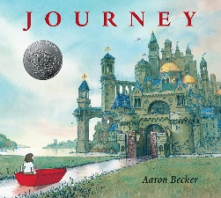  Journey  Writing to entertain  Setting description/ Narrative | 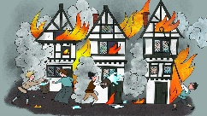  The Great Fire of  London  Writing to inform  Instructions; baking biscuits  Newspaper Report | 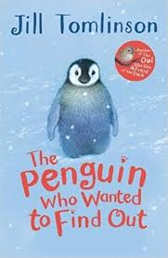  The penguin who wanted to find out  Writing to inform  Non-chronological report  Writing to entertain  Poetry; Haikus | 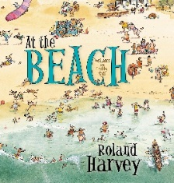  At the beach  Writing to entertain  Setting description; postcard | 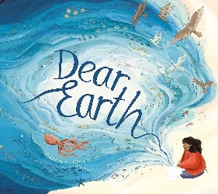  Dear Earth  Writing to inform  Letters | 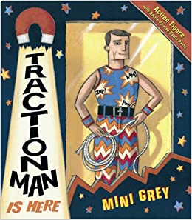  Traction Man  Writing to entertain  Narrative a sequel  Poetry  Cinquain
English Grammar | Expanded noun phrases | Different sentence forms  Using ‘ly’ suffix  Commas to separate items in a list | Homophones/ Near Homophones | Using apostrophes for contracted words  Using possessive apostrophes  Past and present tense | Progressive form in past and present tense | Consolidation of year 2 objectives
Maths | Place value  Addition + Subtraction | Addition + Subtraction  Shape | Money  Multiplication + Division | Multiplication + Division  Length + Height  Mass, Capacity + Temperature | Fractions  Time | Statistics  Position + Direction
Science | Health | Materials | Living Things and their habitats | Animals | Plants | Key scientists
Humanities | Geography: Journey-Food | History: Bonfire Night- The Great Fire of London | Geography: Seasons | History: Holidays | Geography: Our Wonderful World | History: Our Local Heros
Art / DT | Art: Textured art using clay | DT: Mechanisms- Wheels and axles | Art: Printing | DT: Mechanisms- Making a ferris wheel | DT: Food; Wrap | Art: Painting; Pop art
Computing | Information technology around us | Digital phtography | Making music | Programming quizzes | Robot algorithms | Pictograms
Music | Hands, Feet, Heart | Christmas production | I wanna play in a band | Zootime | Friendship song | Reflect, Rewind, Replay
PE | Gym  Attack, Defend, Shoot | Dance- Great Fire of London | Gym  Run, Jump and Throw | Cricket  Dance; the Jungle | Run, Jump and Throw  Hit, Catch and Return | Dance; Superheros  Attack, Defend and Shoot
PSHE | Me and my relationships | Valuing Difference | Emotional Wellbeing | Life Online | Keeping Safe | Living in the wider world

