Your child is in the Read Write Inc. Blue Group
In this Read Write Inc. group children will continue to reinforce their knowledge of Set 2 sounds and letter names. They will also be learning Set 3 sounds. When learning their Set 3 speed sounds they will be taught that there are more ways in which the same sounds are written, e.g. ‘ee’ as in tree and ‘ea’ as in tea. They will be working on ‘Blue books’. These are more complex books including fiction and non-fiction titles which provide an opportunity to practise the new sounds they have learned.

There are 20 Set 3 ‘speed sounds’ that are made up of two or three letters which represent just one sound, e.g. ‘ea’ as in tea, ‘ow’ as in cow and ‘are’ as in care. These are also known as ‘digraphs’ or ‘trigraphs’. It is important that your daughter/son does not pronounce these as 2 or 3 separate sounds. When your daughter/son sees the ‘speed sound’ letters together in a word, s/he must say just one sound for these letters. When your daughter/son learns their Set 3 sounds in school they will learn:
- the letters that represent a speed sound e.g. ‘ea’
- a simple picture prompt linked to the ‘speed sound’ and a short phrase to say e.g. ‘cup of tea’.

Set 3 Sounds
ea: cup of tea | oi: spoil the boy | a-e: make a cake
i-e: nice smile | o-e: phone home | u-e: huge brute
aw: yawn at dawn | are: care and share | ur: purse for a nurse
er: better letter | ai: snail in the rain | ow: brown cow
oa: goat in a boat | ew: chew the stew | ire: fire fire
ear: hear with your ear | ure: sure it’s pure | tion: celebration
tious/cious: scrumptious/delicious | e: he, me, we, she, be
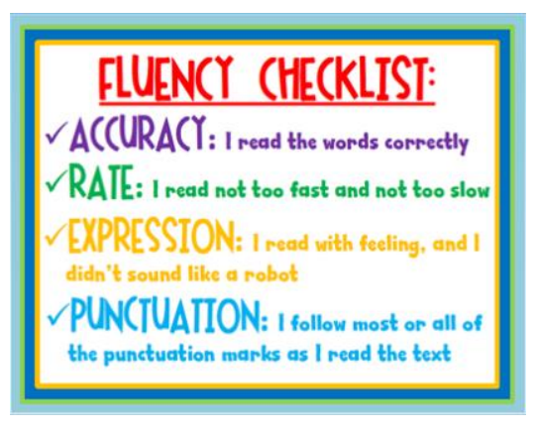
Your child may have remained in this group. This means they still need to consolidate the Set 3 sounds, continue to practice their blending skills and develop their reading fluency.
Fluency is ‘reading a text aloud accurately with appropriate expression and pacing that reflects the meaning of the text’.
Children need to be secure in all of the above and be reading at approximately 70+ WPM (words per minute) to move into the next colour group.

The progress of all children is tracked carefully and all children are re-assessed every 6 weeks and new groups assigned. Where children are making slower progress additional provision is given to support where necessary.
Sound blending group A
Sound blending group B
Sound blending group C
Red Ditties
Green
Purple
Pink
Orange
Yellow
Blue
Grey
Off the Programme

The children in this group will bring home a blue book (on a five-day cycle). They will have read this book in class and completed work around it during their 5 phonics lessons and hence this should be a fluent and easy read for them. The book should be kept at home and read over two evenings – returned on the third day (e.g. book goes home on Tuesday – return to school on Thursday).
In addition to the Read Write Inc books the children will have access to other reading schemes that loosely align to Read Write Inc.
You can also support your child by logging onto the school website – children tab – curriculum areas – Read Write Inc. In here you will find practice cards for all the sounds in the order they are taught and Set 3 practice sheets. Remember the focus for this group is to learn the Set 3 sounds and blend these together with previously taught sounds to make words.

We remind parents that the Read Write Inc books and other reading scheme books have the purpose of developing pupils’ phonic knowledge and ability to decode with automaticity. These books are not necessarily books that help to foster and develop imagination or a love of story and reading. To this end, the children also have the opportunity to visit the library once a week as a class, where they can choose a reading for pleasure book.

We continue to encourage parents to read to your children (even once they are proficient readers). Research shows that children develop strong foundations for all their learning abilities, particularly in the following areas by experiencing being read to regularly.
- Listening skills
- Speech and communication skills
- Thinking skills and logic
- Literacy and numeracy skills

There is lots of information regarding recommended books for each year group on the school website. Please look under the children’s tab – curriculum subject areas – English – reading and also on the individual year group pages.

Additional information regarding Read Write Inc can be found by clicking the links below:
http://www.ruthmiskin.com/en/parents/
https://www.facebook.com/miskin.education
http://www.oxfordowl.co.uk/Reading/
If you have any questions about the Read Write Inc programme or your child’s progress, please don’t hesitate to speak to the class teacher or our Read Write Inc Lead Teachers – Mrs Harmady / Mrs O’Kane.

