Year 5 Curriculum Overview 2023-24
SUBJECT | ADVENT 1 | ADVENT 2 | LENT 1 | LENT 2 | PENTECOST 1 | PENTECOST 2
RE | BRANCH 1 –  Creation & Covenant  A covenant is a binding agreement between God and human beings, which makes them his people. | BRANCH 2 –  Prophecy & Promise  For Christians, Jesus fulfils the promises made to David. | BRANCH 3 –  Galilee to Jerusalem  The Beatitudes describe how faithful Christians should aim to live their lives. | BRANCH 4 –  Desert to Garden  Ash Wednesday marks the beginning of the season of Lent and is the first of the forty days of Lent leading up to Easter. | BRANCH 5 –  To the Ends of the Earth  The effects of confirmation are an increase in the gifts of the Holy Spirit, a closer bond with Jesus and the Church and a desire to spread the Gospel. | BRANCH 6 –  Dialogue & Encounter  The Old Testament is important for Christians because it speaks of God’s covenant with Abraham.  That the Shema prayer is the basic creed of Judaism.
ENGLISH  Writing | AMBITION AND ASPIRATION  Robot Girl    Hidden Figures  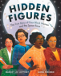 | BELONGING AND EQUALITY  The Lizzie and Belle Mysteries  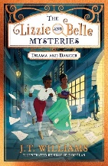  The Lost Thing   | LEGENDS AND FOLKLORE  Rumaysa: A Fairy Tale    The Whale  Ethan and Vita Murrow  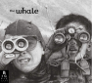 | LESSONS FROM HISTORY  Anne Frank    Children of the Benin Kingdom  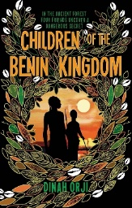 | POWER VS PRINCIPLES  The Island  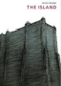  The Man Who Walked Between the Towers   | MYSTERY AND TRUTH  High Rise Mystery  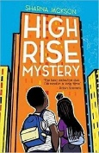  Curiosity  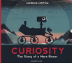
ENGLISH  Grammar | -Revision of prefixes, suffixes and word families, including words with a large number of them [e.g. uncooperativeness or uncoordinated].  -How words are related by meaning as synonyms and antonyms [e.g. big, large, little].  -Use the full range of noun phrases to create descriptions in fiction and non-fiction.  -Use fronted adverbials (phrases and clauses) to create cohesion within and between paragraphs.  -Using the past perfect tense [e.g. He had just arrived the house when the phone started to ring].  -Use of semi-colons to replace a conjunction in a multi-clause sentences [e.g. It’s raining; I’m fed up].  -Use of a wide range of conjunctions, sentence types and lengths to create sentences for varied effects, styles and purposes.  -Use of the semi-colon, colon and dash to mark the boundary between independent clauses [e.g. It’s raining; I’m fed up].  -Use of the colon to introduce a list and use of semi-colons within lists.  -Punctuation of bullet points to list information.  -How hyphens can be used to avoid ambiguity.  -In narratives, create settings, characters and atmosphere by integrating dialogue to convey character and advance the action and select the correct register and level of formality to enhance characterisation.  -Use of the passive to affect the presentation of information in a sentence [e.g. The window in the greenhouse was broken (by me) or It is widely believed that…].  -The difference between structures typical of informal and formal speech and writing [e.g. the use of question tags: He’s your friend, isn’t he?].  -Use of subjunctive forms [such as If I were or Were they to come in some very formal writing and speech].  -Link ideas across paragraphs using a wider range of cohesive devices: repetition of a word or phrase, grammatical connections [e.g. the use of adverbials such as on the other hand, in contrast, or as a consequence], and ellipsis Layout devices [e.g. headings, sub-headings, columns, bullets, or tables, to structure text].  -To know: subject object active passive synonym antonym ellipsis hyphen colon semi-colon bullet points.
ENGLISH  Reading | 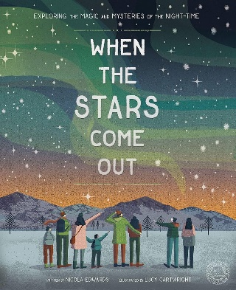 | 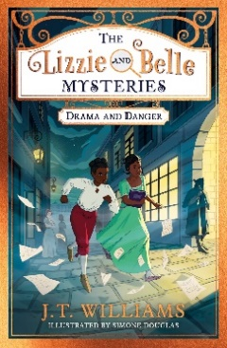 | 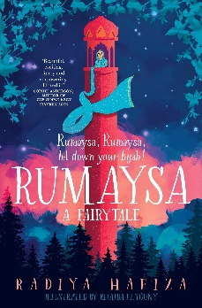 | 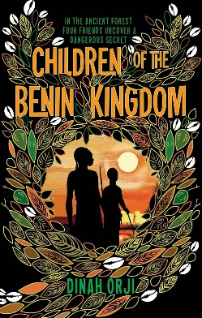 | 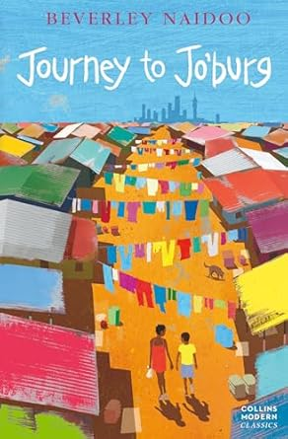 | 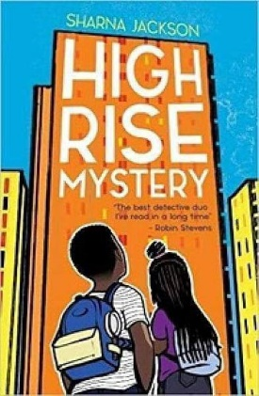
ENGLISH  Spelling | Verb Prefixes  Suffixes: ate, ify, ise | /ee/ spelt /ei/  cious / tious | /shul/  Homophones | ance / ancy  ence / ency | able / ible  ably / ibly | Suffixes  Silent Letters
MATHS | Place Value  Addition and Subtraction | Multiplication and Division  Fractions | Multiplication and Division  Fractions  Decimals and Percentages | Decimals and Percentages  Perimeter and Area  Statistics | Shape  Position and Direction  Decimals | Decimals  Negative Numbers  Converting Units  Volume
SCIENCE | Mixtures and separation | Properties and changes | Earth and Space | Life cycles and reproduction | Imbalanced forces | Human timeline | Making connection
HUMANITIES | Geography:  Local Environment | History:  Anglo-Saxons | History:  Vikings | Geography:  Europe – The Alps | History:  Journeys- why do people go on journeys? | Geography:  Journeys- Trade
ART / DT | ART:  Craft & Design - Architecture | ART:  Painting & Mixed Media - Portraits | DT:  Space Mechanisms – Pop-Up Books | DT:  Digital World – Microbit Monitoring Devices | DT:  Structures - Bridges | ART:  Sculpture & 3D -Interactive Installation
COMPUTING | Sharing Information | Selection in Quizzes | Selection in physical computing | Vector Drawings | Flat-File Databases | Video Editing
MUSIC | Drumming | Drumming | Drumming | Drumming | Drumming | Drumming
SPANISH | Los Instrumentos  (Instruments) | La Familia  (The family) | Mi Clase  (In the classroom) | Qué Fecha Es Hoy?  (What is the date?) | La Ropa  (Clothes) | RECAP
PE | Basketball | Dance | Gymnastics | Tag Rugby | Rounders | Athletics
PSHE | Personal Relationships | Valuing differences | Keeping Safe | Living in the Wider World | Me, My Body, My Health  Emotional Well-Being  Life Cycles

