

MUSIC CURRICULUM

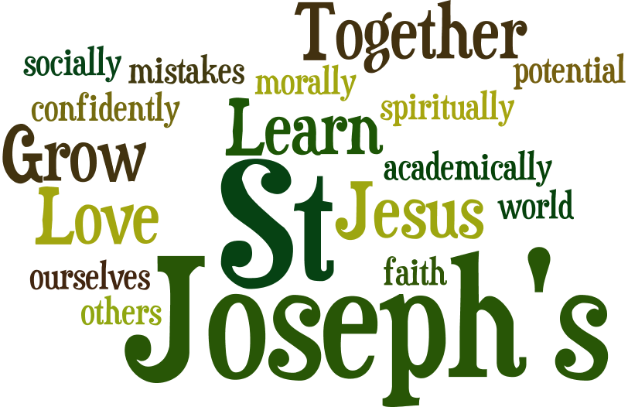

LOVE LEARN GROW
ST JOSEPH’S CURRICULUM – MUSIC
To create a musical atmosphere within St Joseph’s to ensure that all pupil’s get several opportunities to perform, listen to, compose, review and evaluate music.
To provide opportunities for pupil’s to sing and use their voice, learn a musical instrument and give performances to other classes and parents.
To design a curriculum where pupils cover different elements of music, learn important vocabulary and develop a good understanding of how music has changed throughout history.
To develop a curiosity for music, with an understanding and acceptance of the importance of all types of music.
To continue to review and update the music curriculum to ensure that staff and pupil’s experience good musical experiences and improve their knowledge and understanding.
To work on training for staff who teach music to ensure that their subject knowledge is strong in order to inspire future musicians within school as well as let pupil’s experience musicians through lessons and assemblies to understand opportunities that are available to them.
To create musical displays within school to explain our aims within St Joseph’s and display our Music of the Month to inspire pupils.
To include a class poster for each new topic being taught in Music that half term, so children can remember what is being taught when not in a music lesson.

Through the integral nature of music, create a learner who develops fundamental abilities such as: achievement, self-confidence, interaction with and awareness of others, and self-reflection.
Music will develop an understanding of culture and history, both in relation to pupils individually, as well as ethnicities from across the world.
To provide training to support staff subject knowledge to ensure a good music curriculum being taught throughout school.
To plan regular CPD and staff meetings to review the music coverage within school and develop staff understanding and knowledge, including the regular implementation of Class Music Appreciation which will be provided for each month in school.
To employ the specialist teaching services of BMT (Buckinghamshire Music Trust) to teach class-based lessons for Year 4, following the successful implementation of African Drumming in Year 5 and 6.
To use the musical programme ‘Charanga’ to introduce musical concepts and the teaching of key skills in Key Stage 1.
To develop musical appreciation skills to develop an understanding of mood and emotion created by music and how music has changed through periods of time in lessons and during Music of the Month Assemblies.
To continue to build on the bank of instruments within school to support children’s learning and musical experience.
To implement a clear assessment proforma defining what working towards, expected and greater depth looks like in Music for teachers to use in formative assessments on Insight.
IMPACT - GROW
For pupils to understand the relevance of what they are learning within music and to enjoy their musical experiences within school.
To evidence pupil’s work throughout school and ensure they experience performances from others as well as performing themselves.
To continue to check music data and curriculum coverage to best support children’s learning and progression as well as staff knowledge.
To collect pupil interviews throughout the year to ensure that their voice is heard in regards to the school’s music and subject coverage.
To experience a wide range of live music in school, through while school performances from highly experienced, talented musicians.
IMPLEMENTATION - LEARN
INTENT- LOVE

PROGRESSION DOCUMENT – RECORDER YEAR 3
ALL CHILDREN WILL BE ABLE TO: | MOST CHILDREN WILL BE ABLE TO: | SOME CHILDREN WILL BE ABLE TO: | BROADER EXPECTATIONS:
- Know what a recorder is; how to look after it and clean it.  - Hold the recorder correctly to enable correct playing of notes (breathing).  - Know the different parts of the recorder.  - Experiment with making sounds using the recorder.  - To listen carefully to a rhythm and clap in the correct time.  - To know what the note B looks and sounds like.  - To know what the note A looks and sounds like.  - To know what the note G looks and sounds like  - To know what the note E looks and sounds like.  - Play a number of named pieces with support. | - Use their tongues correctly to form the notes and make a clear, consistent sound  - To be able to play and recognise the notes B, A, G and E.  - To experiment with the length of notes.  - Follow a simple notated tune with support  - Play a number of named pieces with some reminders. | - To play notes in time with a given rhythm.  - To follow a variety of simple tunes and rhythms.  - To play the notes B, A, G and E in a simple tune.  - Perform with accuracy, fluency and expression.  - Display a good sense of aural awareness in their control of pulse, rhythm, tempo, dynamics and tone quality. | - Children will learn to work together as a team.  - They will gain confidence in performing together and will respect others’ contributions to the ensemble.  - Their concentration will be improved and they will be highly motivated.  - They will develop greater self-esteem.

Year 4 to be added once Ukulele has been introduced.

PROGRESSION DOCUMENT – AFRICAN DRUMMING YEAR 5 and 6
MOST CHILDREN WILL BE ABLE TO:- | SOME CHILDREN WILL BE ABLE TO:- | SOME CHILDREN WILL HAVE PROGRESSED FURTHER AND BE ABLE TO:- | BROADER EXPECTATIONS:-
- Play the bass, tone and slap strokes with the correct hand position, and with good posture.  - Keep a steady beat.  - Maintain their own rhythm in a piece using more than one part, whilst following a leader.  - Sing a number of different songs with confidence, including maintaining their line in a 2 or 3 part song whilst following a leader.  - Be able to improvise a simple 4 beat rhythm without support.  - Work as part of a small group to create their own rhythm piece.  - Notate their own rhythm piece.  - Understand and use basic dynamics in their playing.  - Understand and follow a simple notated rhythm.  - Play a number of named pieces.  - Display a developing aural awareness in their control of pulse, rhythm, tempo and dynamics. | - Play the bass, tone and slap strokes with some reminders about correct hand position and posture.  - Keep a steady beat whilst watching a leader.  - Maintain their own rhythm with support from a leader.  - Sing single part songs with confidence, but will need extra support to sing songs with more than one part.  - Improvise a simple 4 beat rhythm with support.  - Work as part of a small group to create their own rhythm piece with support from the teacher.  - Follow a simple notated rhythm with support.  - Play a number of named pieces with some reminders. | - Play all 3 strokes with the correct hand position and posture without reminders.  - Lead a group in keeping a steady beat.  - Lead a group in their part in a 2 or 3 part rhythm.  - Sing as a soloist with a good sense of the shape of the melody and with good projection.  - Sing as a leader in a 2 or 3 part song.  - Improvise a more complex rhythm.  - Act as a leader when working in a small group to create their own rhythm piece.  - Read notated rhythms reliably and with confidence.  - Perform with accuracy, fluency and expression and display a good sense of aural awareness.  - Talk about their performances with clear musical understanding using musical language and suggest how they can improve their playing. | - Children will learn to work together as a team.  - They will gain confidence in performing together and will respect others’ contributions to the ensemble.  - Their concentration will be improved and they will be highly motivated.  - They will develop greater self-esteem.

MUSIC – YEAR 1 – TOPIC/SKILLS AND KNOWLEDGE

Term | Topic | KNOWLEDGE AND UNDERSTANDING | SKILLS
Advent 1 | Charanga Creative Music Scheme  Unit 1: Rhyming in time  Songs: Find the Beat and Dancing Dinosaurs | By the end of this unit, children will be able to:  - Move in time with the beat/pulse, responding to different tempos (speeds).  - Chant, rap, and sing using different voices following simple cues such as starting together. | To move in time with the beat or pulse of the music.  To differentiate between singing and chanting using voice modulation.  To identify tempo changes.  To compare and contrast different musical tempos and styles.  To perform movements and chants synchronised with music.  To perform energetically to fast music.  To integrate musical concepts in a performance. To demonstrate their understanding and application of musical concepts through performing.  To express ideas through music and movement.
Advent 2 | CHRISTMAS PRODUCTION | To perform in front of an audience as part of KS1 Christmas Production. | To record the performance and reflect on how they were feeling about it.  To choose relevant songs and perform it as a group/ solo.
Lent 1 | Charanga Creative Music Scheme  Unit 3: Music Inspired by the World Around Us  Songs: In the Sea | By the end of this unit, the children will be able to:  - Listen attentively and with understanding to music from different historical periods.  - Understand that music can tell a story.  - Sing songs with a clear understanding of tempo, pitch and ensemble. | To listen to music from different eras and discuss their opinions about it.  To form their own opinion of a song or piece of music.  To sing expressively while listening to peers to develop ensemble awareness.  To explore energy and passion, moving freely to create interpretive responses and discussing storytelling elements in music.  To identify and imitate body and vocal sounds.
Lent 2 | Charanga Creative Music Scheme  Unit 4: Exploring Rhythm and Patterns  Songs: Hey You and Rhythm Grid | By the end of this unit, children will:  - Understand that an ostinato is a recurring pattern.  - Copy and compose simple rhythm patterns (Call and Response). | To explore repeated rhythmic patterns, or ostinatos, and how they align with a steady beat.  To listen to clear, rhythm-driven pieces and move in time with the pulse, progressing from large body movements to smaller gestures.  To add variation through body percussion, dynamics, and whispers to a song.  To explore the connection between rhythm, words, and melody, starting with vocal warm-ups that use familiar patterns to reinforce pulse awareness.  To pay attention to rests and timing.  To compose and perform their own rhythmic creations.
Pentecost 1 | Charanga Creative Music Scheme  Unit 5: Sounds and Pictures  Songs: RSNO’s Yoyo and the Little Auk | By the end of the unit, children can:  - Match and create pictures/symbols to represent sound.  - Capture, sequence and change sounds to make a musical story. | To explore fundamental elements: pitch, tempo, dynamics, and articulation.  To develop awareness of high/low, fast/slow, loud/quiet, smooth/spiky sounds through listening, movement, and vocal activities.  To know simple Italian terms (e.g., forte) and respond physically to music.  To engage with instruments to recognise musical features and express ideas through movement and voice.  To creating sound pictures and graphic scores.  To use instruments, voices, and body percussion to represent characters, actions, and scenes from a story, experimenting with dynamics, order, and repetition.  To focus on composing and performing their own rhythmic creations.
Pentecost 2 | Charanga Creative Music Scheme  Unit 6: Highs and Lows  Songs: Friendship Song | By the end of the unit, children can:  - Understand the difference between a rhythm and a pitch pattern.  - Identify different pitches (highs and lows) in music and in sounds around the school. | To explore pitch awareness (high and low sounds) through listening, movement, and class discussions about how music makes them feel.  To use a match and interpret visual cues to simple sounds.  To develop confidence in recognising and performing pitch patterns.  To explore rhythmic patterns through movement, claps, and stomps.  To encourage confident vocal performance with clear diction, and an awareness of pitch and rhythm in a group context.

MUSIC – YEAR 2 – TOPIC/SKILLS AND KNOWLEDGE

Term | Topic | KNOWLEDGE AND UNDERSTANDING | SKILLS
Advent 1  Charanga | Charanga Creative Music Scheme  Unit 4: Questions and Answers  Songs: Hello and Hey Friend | To develop listening skills and sound awareness by helping children identify instrumental timbre.  To respond to rhythm through movement.  To build confidence to sing and perform simple musical patterns. |  | To create rhythmic question and answer phrases.  To learn basic skills in musical improvisation.  To practise improvising music and responding musically to improvised questions. To rehearse their performing skills for a friendly audience.  To recognise and appreciate the musical structure of Ravel’s ‘Bolero’.  To identify instruments and voice timbres in ‘Amazing Grace’.
Advent 2 | CHRISTMAS PRODUCTION | To perform in front of an audience as part of KS1 Christmas Production. |  | To record the performance and reflect on how they were feeling about it.  To choose relevant songs and perform it as a group/ solo
Lent 1  Charanga | Unit: Sound and Symbol 1  Theme: A Glockenspiel Adventure! | Play three notes on a tuned instrument, understanding which is the lowest, middle and highest pitch.  2. Recognise the sound of different families of instruments and how each makes its sounds.  . |  | to perform independently or collaboratively, demonstrating ensemble awareness, technical skills, and expressive musicality  reflecting on performances builds critical listening, self-evaluation, and confidence.  perform their first complete glockenspiel piece, integrating notes B, A, and G.  learn to read and play these notes within simple pieces, applying crotchets, minim rests, and 4/4 time signatures.
Lent 2  Charanga | Unit: Sound and Symbol 2  Theme: A Glockenspiel Adventure! | Recognise and write music using dots (blobs), sticks and stave notation.  2. Understand and use gradations of dynamics, such as crescendo (getting louder), to add interest to a performance. |  | Role rotations build confidence in solo, paired, and group performances  consolidate B, A, and newly introduced G notes, practising patterns and extended rhythms, and exploring dynamic markings, including mezzo forte.
  They develop posture, beater technique, and accuracy on glockenspiels while revisiting familiar pieces and practising ensemble awareness.
  Dynamics are introduced through forte and piano, encouraging control of volume in different contexts.
  Children are also introduced to brass instruments, where they explore timbre, embouchure, and sound production.
Pentecost 1 | Around the World  Hand, Feet, Heart | 1. Listen to music from around the world.  2. Explore tempo, understanding that music can be at different speeds. |  | Children examine message-driven music, tempo, and style with “Bring Him Back Home,” identifying instruments and discussing its purpose. ● Instrumental practice on “Hands, Feet, Heart” progresses from tapping rhythms to performing Medium parts with backing tracks. ● Singing and echo activities consolidate pitch, rhythm, and expressive performance.  Reflection encourages sharing favourites, challenges, and insights, consolidating global music awareness, ensemble skills, and aural understanding.
Pentecost 2 | The Power Of Communication | Improvisation and Composition
Pentecost 2 | The Power Of Communication | 1. Communicate the meaning of the song with our voices and sign language.  2. Sing short vocal phrases independently. | isten actively to the song, exploring the meanings of words and their connections to emotions such as worry or sadness.  explore emotions and self-expression through listening and appraising  s develop pitch, vocal expression, and ensemble awareness.  They learn to give and receive constructive feedback in a classroom context, and to discuss working together, sounding good together, and performing expressively.  Rehearsals strengthen timing, confidence, and expressive delivery. 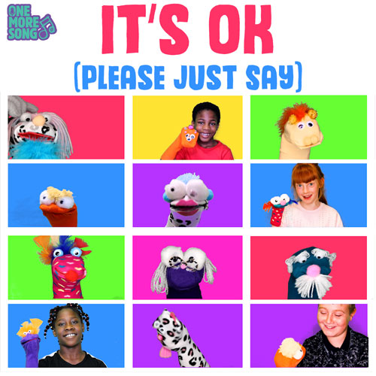

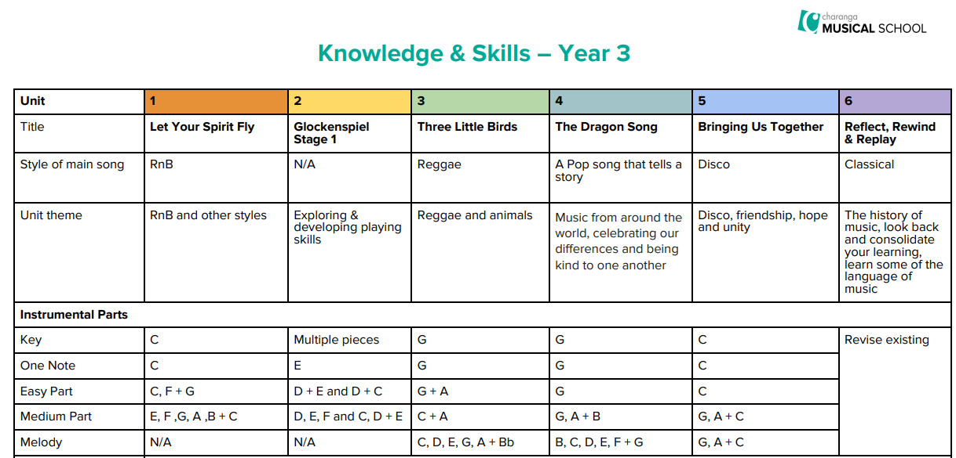
Passion Play Production
Recorders
Stage 2
Recorders
Stage 2
Recorders
Stage 2
Recorders
Stage 2

MUSIC – YEAR 3 – TOPIC/SKILLS AND KNOWLEDGE

Term | Topic | KNOWLEDGE AND UNDERSTANDING | SKILLS
Advent 1 | Music Title: Let Your Spirit Fly by Joanna Mangona  Style: RnB  Music Outcome: To learn about the RnB style of music and begin to play a musical instrument with musical notation. | Listen and Appraise
Advent 1 |  | To know five songs from memory and who sang them or wrote them.  ● To know the style of the five songs.  ● To choose one song and be able to talk about:  - ○ Its lyrics: what the song is about ○ Any musical dimensions featured in the song, and where they are used (texture, dynamics, tempo, rhythm and pitch)  - ○ Identify the main sections of the song (introduction, verse, chorus etc.)  - ○ Name some of the instruments they heard in the song |  | To confidently identify and move to the pulse.  To think about what the words of a song mean.  To take it in turn to discuss how the song makes them feel.  Listen carefully and respectfully to other people’s thoughts about the music.
Advent 1 |  | Musical notation –  Recognising and playing crochet and quaver  Musical notes on the stave - a and b
Advent 2 | Recorder and Christmas Carol Concert | Playing an Instrument
Advent 2 | Recorder and Christmas Carol Concert | To know and be able to talk about:  ● The instruments used in class (a glockenspiel, a recorder) |  | To treat instruments carefully and with respect.  To play any one, or all of four, differentiated parts on a tuned instrument – a one-note, simple or medium part or the melody of the song) from memory or using notation.  To rehearse and perform their part within the context of the Unit song.  To listen to and follow musical instructions from a leader.
Advent 2 | Recorder and Christmas Carol Concert | Musical notation –  Recognising and playing minim, dotted minim and time signature  Musical notes on the stave - g
Lent 1 | Recorder | Musical notation –  Recognising and playing new time signatures  Musical notes on the stave - e and c
Lent 2 | PASSION PLAY PRODUCTION | Performance
Lent 2 | PASSION PLAY PRODUCTION | To perform in front of an audience as part of Passion Play Production. | To communicate the meaning of the words and clearly articulate them  To talk about the best place to be when performing and how to stand or sit  To record the performance and say how they were feeling.
Lent 2 | PASSION PLAY PRODUCTION | To know and be able to talk about:  Singing in a group can be called a choir  Leader or conductor: A person who the choir or group follow  Songs can make you feel different things e.g. happy, energetic or sad  Singing as part of an ensemble or large group is fun, but that you must listen to each other  To know why you must warm up your voice | To sing in unison and in simple two-parts.  To demonstrate a good singing posture.  To follow a leader when singing.  To enjoy exploring singing solo.  To sing with awareness of being ‘in tune’.  To have an awareness of the pulse internally when singing.
Pentecost 1 | Recorder | Playing instruments
Pentecost 1 | Recorder | To know and be able to talk about:  ● The instruments used in class (a glockenspiel, a recorder) |  | To treat instruments carefully and with respect.  To play any one, or all of four, differentiated parts on a tuned instrument – a one-note, simple or medium part or the melody of the song) from memory or using notation.  To rehearse and perform their part within the context of the Unit song.  To listen to and follow musical instructions from a leader.
Pentecost 1 | Recorder | Musical notation –  Recognising and playing semibreve and slurs  Musical notes on the stave - d and f
Pentecost 2 | Recorder | Consolidation of skills taught and performance skills.  To provide a whole year performance on the recorder during the end of Music Concert.

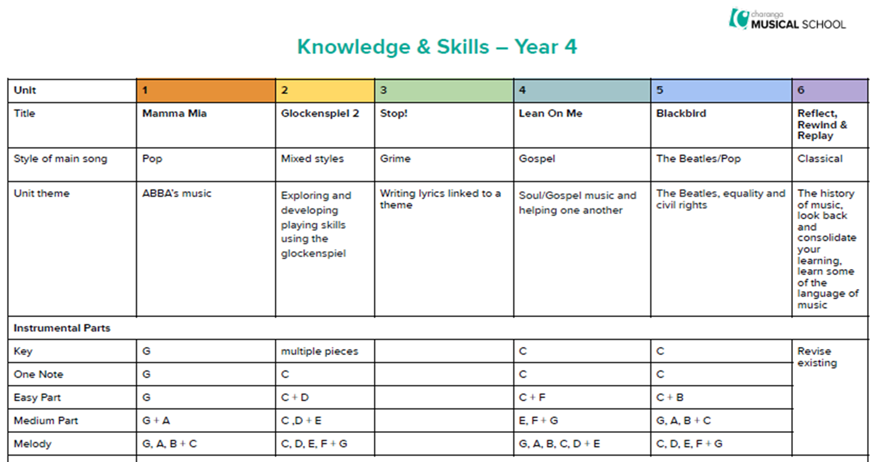
Passion Play Production

MUSIC – YEAR 4– TOPIC/SKILLS AND KNOWLEDGE

Term | Topic | KNOWLEDGE AND UNDERSTANDING | SKILLS
Advent 1  Charanga | Music title: Lean On Me – Bill Withers  Style: Gospel  Outcome: To learn Soul/ Gospel music (helping one another). | Games
Advent 1  Charanga |  | To know and be able to talk about:  - How pulse, rhythm and pitch work together and their differences  - Pulse: Finding the pulse – the heartbeat of the music  - Rhythm: the long and short patterns over the pulse  - Pitch: High and low sounds that create melodies  - How to keep the internal pulse  - Musical Leadership: creating musical ideas for the group to copy or respond to. | To engage in warm up games and bronze, silver and gold challenges that embed the musical elements (pulse, rhythm and pitch):  1. Find the pulse  2. Rhythm copy back  3. Pitch copy back using 2 notes  4. Pitch copy back and vocal warm-ups.
Advent 2 | Music title: Blackbird - Beatles  Style: Pop - The Beatles  Outcome: To learn the style of the Beatles music (equality and civil rights). | Improvisation and Composition
Advent 2 |  | To know and be able to talk about improvisation:  - Improvisation is making up your own tunes on the spot and it is not written down  - To know that using one or two notes confidently is better than using five  - To know that if you improvise using the notes you are given, you can’t make a mistake.  To know and be able to talk about composition:  - Music created by you and kept in some way. It’s like writing a story and can be played or performed again  Different ways of recording compositions (letter names/ symbols/ audio). | To improvise using instruments in the context of the song they are learning to perform.  There are activities within the three challenges: 1. Bronze  2. Silver  3. Gold.  To create at least one simple melody using one, three or five different notes  To plan and create a section of music that can be performed within the context of the lesson’s song  To talk about what is created  To listen to and reflect upon the developing composition and make musical decisions about pulse, rhythm, pitch, dynamics and tempo  To record the composition in an appropriate way that recognised the connection between sound and symbol (graphic/ pictorial/ notation).
Lent 1  Charanga | Music title: Stop! – Joanna Mangona  Style: Grime  Outcome: To write lyrics linked to a theme. | Singing
Lent 1  Charanga |  | To know and be able to talk about:  - Leader or conductor: A person who the choir or group follow  - Songs can make you feel different things e.g. happy, energetic or sad  - Singing as part of an ensemble or large group is fun, but that you must listen to each other  - Texture: How a solo singer makes a thinner texture than a large group  - To know why you must warm up your voice. | To sing in unison and in simple two-parts  To demonstrate a good singing posture  To follow a leader when singing  To enjoy exploring singing solo  To sing with awareness of being ‘in tune’  To re-join the song if lost  To listen to the group when singing.
Lent 2 | PASSION PLAY PRODUCTION | Performance
Lent 2 | PASSION PLAY PRODUCTION | To perform in front of an audience as part of Passion Play Production. | To present a musical performance designed to capture the audience  To communicate the meaning of the words and clearly articulate them  To talk about the best place to be when performing and how to stand or sit  To record the performance and say how they were feeling and what they were pleased with.
Pentecost 1  Charanga | Music title: Mamma Mia - ABBA  Style: Pop  Outcome: Learn the style of ABBA’s music. | Listen and Appraise
Pentecost 1  Charanga |  | To know some songs from memory and who sang them or wrote them  To know the style of the songs  To choose one song and be able to talk about:  - Some of the style indicators of that song (musical characteristics that give the song its style)  - The lyrics: what the song is about  - Any musical dimensions featured in the song and where they are used (texture, dynamics, tempo, rhythm and pitch)  - Identify the main sections of the song (introduction, verse, chorus etc)  Name some of the instruments they heard in the song. | To confidently identify and move to the pulse  To talk about the musical dimensions working together in the songs e.g. if the song gets louder in the chorus (dynamics)  To talk about the music and how it makes them feel  To listen carefully and respectfully to other people’s thoughts about the music  To use musical language (musical elements) when talking about songs.
Pentecost 2  Charanga | Music title: Glockenspiel Stage 2  Style: Mixed styles  Outcome: To explore and develop playing skills using the glockenspiel. | Playing instruments
Pentecost 2  Charanga |  | To know and be able to talk about:  - The instruments used in class (a glockenspiel and chime bars)  Other instruments they might play or be played in a band or orchestra or by their friends. | To treat instruments carefully and with respect  To play any one, or all four, differentiated parts on a tuned instrument – a one-note, simple or medium part or the melody of the song from memory or using notation  To rehearse and perform their part within the context of the lesson’s song  To listen to and follow musical instructions from a leader  To experience leading the playing by making sure everyone plays in the playing section of the song.  To provide a whole year performance of Mamma Mia during the end of Music Concert.

YEAR 5 SKILLS AND KNOWLEDGE TAUGHT OVER WHOLE YEAR IN AFRICAN DRUMMING/ANNUAL MUSIC CONCERT
KNOWLEDGE AND UNDERSTANDING | SKILLS
Improvisation and Composition
To know and be able to talk about:  - A composition: music that is created by you and kept in some way. It’s like writing a story. It can be played or performed again to your friends.  - A composition has pulse, rhythm and pitch that work together and are shaped by tempo, dynamics, texture and structure  - Notation: recognise the connection between sound and symbol  To know and be able to talk about improvisation:  - Improvisation is making up your own tunes on the spot  - When someone improvises, they make up their own tune that has never been heard before. It is not written down and belongs to them.  - To know that using one, two or three notes confidently is better than using five  - To know that if you improvise using the notes you are given, you cannot make a mistake  - To know that you can use some of the riffs and licks you have learnt in the Challenges in your improvisations  - To know three well-known improvising musician | - Create simple melodies using up to five different notes and simple rhythms that work musically with the style of the Unit song.  - Explain the keynote or home note and the structure of the melody.  - Listen to and reflect upon the developing composition and make musical decisions about how the melody connects with the song.  - Record the composition in any way appropriate that recognises the connection between sound and symbol (e.g. graphic/pictorial notation).
Singing
To know and confidently sing five songs and their parts from memory, and to sing them with a strong internal pulse.  To know about the style of the songs so you can represent the feeling and context to your audience  - To choose a song and be able to talk about:  - Its main features  - Singing in unison, the solo, lead vocal, backing vocals or rapping  - To know what the song is about and the meaning of the lyrics  - To know and explain the importance of warming up your voice | - To sing in unison and to sing backing vocals.  - To demonstrate a good singing posture.  - To follow a leader when singing.  - To experience rapping and solo singing.  - To listen to each other and be aware of how you fit into the group. To sing with awareness of being ‘in tune’.
Performance
To know and be able to talk about:  - Performing is sharing music with an audience with belief  - A performance doesn’t have to be a drama! It can be to one person or to each other  - Everything that will be performed must be planned and learned  - You must sing or rap the words clearly and play with confidence  - A performance can be a special occasion and involve an audience including of people you don’t know  - It is planned and different for each occasion  - A performance involves communicating ideas, thoughts and feelings about the song/music | - To choose what to perform and create a programme.  - To communicate the meaning of the words and clearly articulate them.  - To talk about the venue and how to use it to best effect.  - To record the performance and compare it to a previous performance.  - To discuss and talk musically about it – “What went well?” and “It would have been even better if...?
Listen and Appraise
To know five songs from memory, who sang or wrote them, when they were written and why?  To know the style of the songs and to name other songs from the Units in those styles.  To choose three or four other songs and be able to talk about:  - The style indicators of the songs (musical characteristics that give the songs their style)  - The lyrics: what the songs are about  - Any musical dimensions featured in the songs and where they are used (texture, dynamics, tempo, rhythm, pitch and timbre)  - Identify the structure of the songs (intro, verse, chorus etc.)  - Name some of the instruments used in the songs  - The historical context of the songs. What else was going on at this time, musically and historically?  - Know and talk about that fact that we each have a musical identity | To identify and move to the pulse with ease.  To think about the message of songs.  To compare two songs in the same style, talking about what stands out musically in each of them, their similarities and differences.  Listen carefully and respectfully to other people’s thoughts about the music.  Use musical words when talking about the songs.  To talk about the musical dimensions working together.  Talk about the music and how it makes you feel, using musical language to describe the music.
Playing instruments
To know and be able to talk about:  Different ways of writing music down – e.g. staff notation, symbols  The notes C, D, E, F, G, A, B + C on the treble stave  The instruments they might play or be played in a band or orchestra or by their friends | Play a musical instrument with the correct technique:  Select and learn an instrumental part that matches their musical challenge, using one of the differentiated parts – a one-note, simple or medium part or the melody of the song from memory or using notation. To rehearse and perform their part  To listen to and follow musical instructions from a leader.  To lead a rehearsal session.

YEAR 6 SKILLS AND KNOWLEDGE TAUGHT OVER WHOLE YEAR IN AFRICAN DRUMMING/YEAR 6 PERFORMANCE
KNOWLEDGE AND UNDERSTANDING | SKILLS
Improvisation and Composition
To know and be able to talk about:  - A composition: music that is created by you and kept in some way. It’s like writing a story. It can be played or performed again to your friends.  - A composition has pulse, rhythm and pitch that work together and are shaped by tempo, dynamics, texture and structure  - Notation: recognise the connection between sound and symbol  To know and be able to talk about improvisation:  - Improvisation is making up your own tunes on the spot  - When someone improvises, they make up their own tune that has never been heard before. It is not written down and belongs to them.  - To know that using one, two or three notes confidently is better than using five  - To know that if you improvise using the notes you are given, you cannot make a mistake  - To know that you can use some of the riffs and licks you have learnt in the Challenges in your improvisations  - To know three well-known improvising musician | - Create simple melodies using up to five different notes and simple rhythms that work musically with the style of the Unit song.  - Explain the keynote or home note and the structure of the melody.  - Listen to and reflect upon the developing composition and make musical decisions about how the melody connects with the song.  - Record the composition in any way appropriate that recognises the connection between sound and symbol (e.g. graphic/pictorial notation).
Singing
To know and confidently sing five songs and their parts from memory, and to sing them with a strong internal pulse.  To choose a song and be able to talk about:  - Its main features  - Singing in unison, the solo, lead vocal, backing vocals or rapping  - To know what the song is about and the meaning of the lyrics  - To know and explain the importance of warming up your voice | - To sing in unison and to sing backing vocals.  - To enjoy exploring singing solo.  - To listen to the group when singing.  - To demonstrate a good singing posture.  - To follow a leader when singing.  - To experience rapping and solo singing.  - To listen to each other and be aware of how you fit into the group.  - To sing with awareness of being ‘in tune’.
Performance
To know and be able to talk about:  - Performing is sharing music with an audience with belief  - A performance doesn’t have to be a drama! It can be to one person or to each other  - Everything that will be performed must be planned and learned  - You must sing or rap the words clearly and play with confidence  - A performance can be a special occasion and involve an audience including of people you don’t know  - It is planned and different for each occasion  - A performance involves communicating ideas, thoughts and feelings about the song/music | - To choose what to perform and create a programme.  - To communicate the meaning of the words and clearly articulate them.  - To talk about the venue and how to use it to best effect.  - To record the performance and compare it to a previous performance.  - To discuss and talk musically about it – “What went well?” and “It would have been even better if...?
Listen and Appraise
To know five songs from memory, who sang or wrote them, when they were written and, if possible, why?  To know the style of the five songs and to name other songs from the Units in those styles.  To choose two or three other songs and be able to talk about:  - Some of the style indicators of the songs (musical characteristics that give the songs their style)  - The lyrics: what the songs are about  - Any musical dimensions featured in the songs and where they are used (texture, dynamics, tempo, rhythm and pitch)  - Identify the main sections of the songs (intro, verse, chorus etc.)  - Name some of the instruments they heard in the songs  - The historical context of the songs. What else was going on at this time? | - To identify and move to the pulse with ease.  - To think about the message of songs.  - To compare two songs in the same style, talking about what stands out musically in each of them, their similarities and differences.  - Listen carefully and respectfully to other people’s thoughts about the music.  - When you talk try to use musical words.  - To talk about the musical dimensions working together in the Unit songs.  - To talk about the music and how it makes you feel.
Playing instruments
To know and be able to talk about:  - Different ways of writing music down – e.g. staff notation, symbols  - The notes C, D, E, F, G, A, B + C on the treble stave  - The instruments they might play or be played in a band or orchestra or by their friends | Play a musical instrument with the correct technique:  Select and learn an instrumental part that matches their musical challenge, using one of the differentiated parts – a one-note, simple or medium part or the melody of the song from memory or using notation. To rehearse and perform their part  To listen to and follow musical instructions from a leader.  To lead a rehearsal session.

