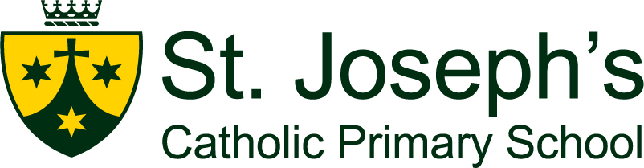

Free KS2 learning support

Dear Parent / Guardian,

We are pleased to let you know that St Joseph’s Catholic Primary School has partnered with Atom Learning, the leading Key Stage 2 learning and 11+ preparation website, to provide free KS2 learning to primary school children who are eligible for Pupil Premium.

Eligible students will receive access to Atom Home for free (normally £575.90 a year).
Atom Learning is a viable, more child-centric alternative to private tuition that we believe is a non-stressful and enjoyable way of making progress at KS2 and, when relevant, preparing for exams. There is a 5-day free trial of Atom available for non-PP families.

The application link can be found on our school website.

What is Atom Home?
Atom Home is an online learning and exam preparation platform for ages 7-11.
Covering English, maths, science, verbal reasoning and non-verbal reasoning, students can explore learning resources, mock tests, video tutorials, and exam preparation materials.

Do you know someone who is eligible?
If you know someone whose child is in need of extra Key Stage 2 learning support (they do not need to be attending St Joseph’s), please share this link with them:
https://atomlearning.com/pupil-premium/primary-schools

After completing the form on this page, their primary school will receive a notification to verify their pupil premium eligibility. Once confirmed by their school, their Atom Home account will be created.
If you would like to find out more, please email pupilpremium@atomlearning.com.

Kind regards

C Lovegrove
Headteacher

