


RWInc
Home Support Booklet 2
Purple Group
Dear Parents

At St Joseph’s we use Ruth Miskin’s Read Write Inc Programme to teach phonics. It was first created by Ruth Miskin in 2002. It is the UK’s leading synthetic phonics programme and is used by over 5000 schools, who work with expert trainers to teach every child how to read

The Read Write Inc Journey lasts from Reception – Year 2, by which time the children should have mastered all the components of successful reading, such as having good phonic knowledge, blending skills, comprehension and be able to read with intonation and expression.

It is absolutely vital that the children master the foundations of reading at this early stage. It is essential that they ‘keep up’ as trying to catch up leaves them lagging behind their peers and unable to access the wider curriculum as they move through education. The ability to access all subject areas is heavily dependent on the ability to read fluently.

This book is aimed at helping you to support your child in becoming fluent with set 1 sounds and being able to blend these into words, as well as reading short ‘dittys’ fluently.
In the booklet are:
- QR codes – linking to short engaging films about each set 1 single sound
- QR codes – linking to short engaging films about Special Friends.
- Wordtime 1.1-1.7 – Sounds used / words children should be reading and QR codes to films that support your child in blending these sounds into words (1.6 onwards involves Special Friends – where 2 letters together make one sound).
- At the end there are some further QR codes to support the initial steps in blending.
It will benefit your child enormously if you can engage in some short reading activity from this booklet daily.
Minimum Expected Progress to be on track
 | Reception | Year 1 | Year 2
End of Autumn Half Term | First 16 Sounds Set 1 | Read Purple Storybooks  Read Set 2 sounds | Read Blue Storybooks with increasing fluency and comprehension
Christmas | Read all set 1 single sounds  Blend sounds into words orally | Read Pink Storybooks  Read First 9 set 3 sounds | Read Grey storybooks
February Half Term | Blend sounds into words  Read short Ditty Stories  Read Set 1 Special Friends | Read Orange Storybooks  Read 17 set 3 sounds | Read Grey Storybooks with fluency and comprehension
Easter | Read Red Storybooks | Read Yellow storybooks  Read all Set 3 sounds + additional sounds | Comprehension Group
May Half Term | Read Green Storybooks | Read Yellow storybooks | Comprehension Group
Summer | Read Green or Purple Storybooks  First 6 set 2 sounds | Read Blue Storybooks | Comprehension Group

Set 2 sounds.

Below are short clips for each of these sounds.
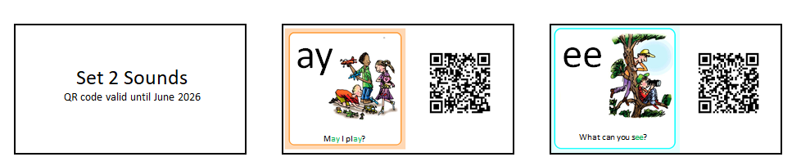
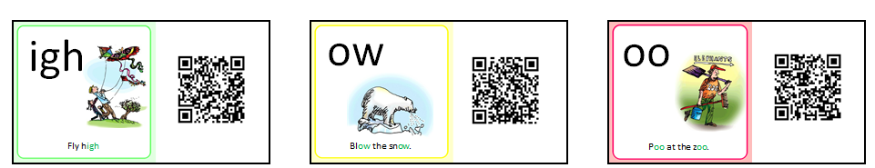
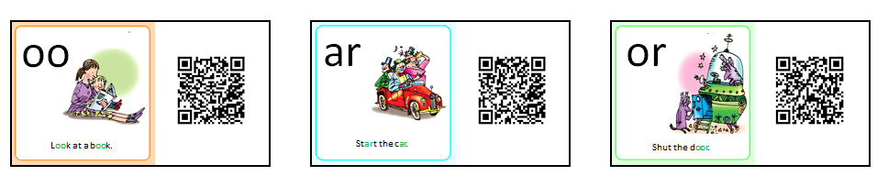
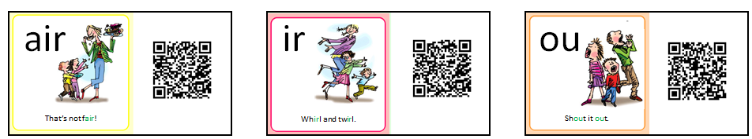
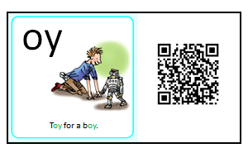

Children Need to read words with Set 2 Special Friends

Below are film clips to support with this:




ay ee igh ow





oo oo ar or





air ir ou oy

Children need to read the words below speedily (at a glance)
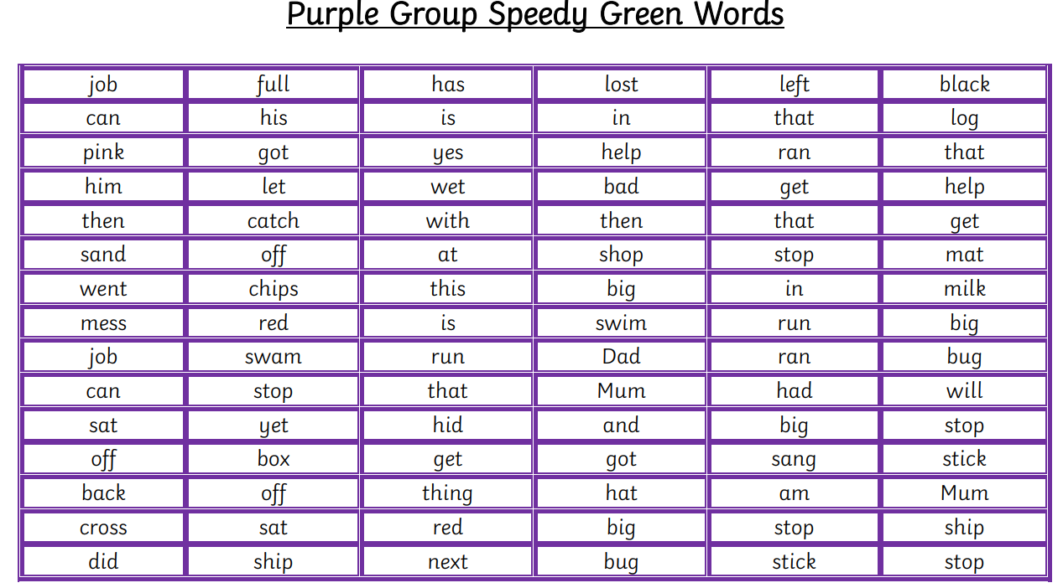

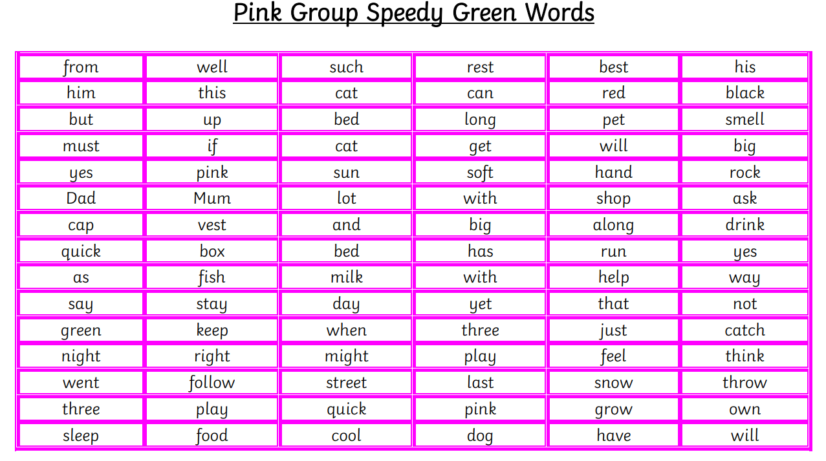

Red words are non-decodable words. The children cannot Fred Talk these – they just need to learn them. They make up most of the content of what we read.

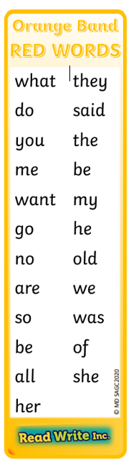
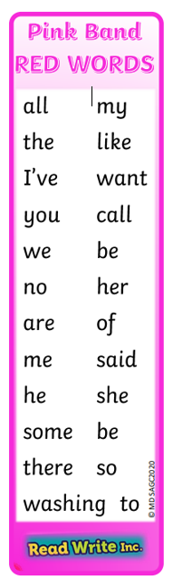
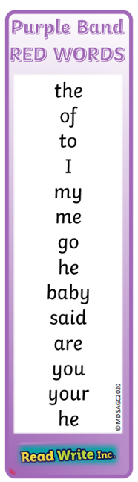

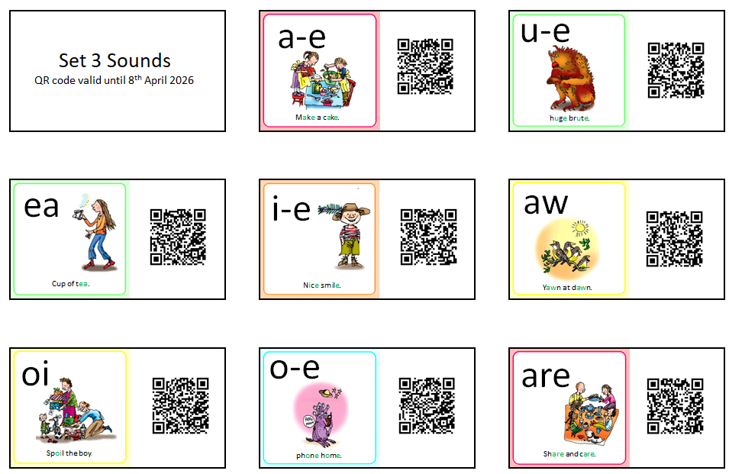
Set 3 Sounds

