


RWInc
Home Support Booklet 2
Group 1c and Ditty
Dear Parents

At St Joseph’s we use Ruth Miskin’s Read Write Inc Programme to teach phonics. It was first created by Ruth Miskin in 2002. It is the UK’s leading synthetic phonics programme and is used by over 5000 schools, who work with expert trainers to teach every child how to read

The Read Write Inc Journey lasts from Reception – Year 2, by which time the children should have mastered all the components of successful reading, such as having good phonic knowledge, blending skills, comprehension and be able to read with intonation and expression.

It is absolutely vital that the children master the foundations of reading at this early stage. It is essential that they ‘keep up’ as trying to catch up leaves them lagging behind their peers and unable to access the wider curriculum as they move through education. The ability to access all subject areas is heavily dependent on the ability to read fluently.

This book is aimed at helping you to support your child in becoming fluent with set 1 sounds and being able to blend these into words, as well as reading short ‘dittys’ fluently.
In the booklet are:
- QR codes – linking to short engaging films about each set 1 single sound
- QR codes – linking to short engaging films about Special Friends.
- Wordtime 1.1-1.7 – Sounds used / words children should be reading and QR codes to films that support your child in blending these sounds into words (1.6 onwards involves Special Friends – where 2 letters together make one sound).
- At the end there are some further QR codes to support the initial steps in blending.
It will benefit your child enormously if you can engage in some short reading activity from this booklet daily.
Minimum Expected Progress to be on track
 | Reception | Year 1 | Year 2
End of Autumn Half Term | First 16 Sounds Set 1 | Read Purple Storybooks  Read Set 2 sounds | Read Blue Storybooks with increasing fluency and comprehension
Christmas | Read all set 1 single sounds  Blend sounds into words orally | Read Pink Storybooks  Read First 9 set 3 sounds | Read Grey storybooks
February Half Term | Blend sounds into words  Read short Ditty Stories  Read Set 1 Special Friends | Read Orange Storybooks  Read 17 set 3 sounds | Read Grey Storybooks with fluency and comprehension
Easter | Read Red Storybooks | Read Yellow storybooks  Read all Set 3 sounds + additional sounds | Comprehension Group
May Half Term | Read Green Storybooks | Read Yellow storybooks | Comprehension Group
Summer | Read Green or Purple Storybooks  First 6 set 2 sounds | Read Blue Storybooks | Comprehension Group

The first thing to master is knowing all the Set 1 single sounds and being able to recognise them speedily (at a glance). These clips will help cement sound recognition.
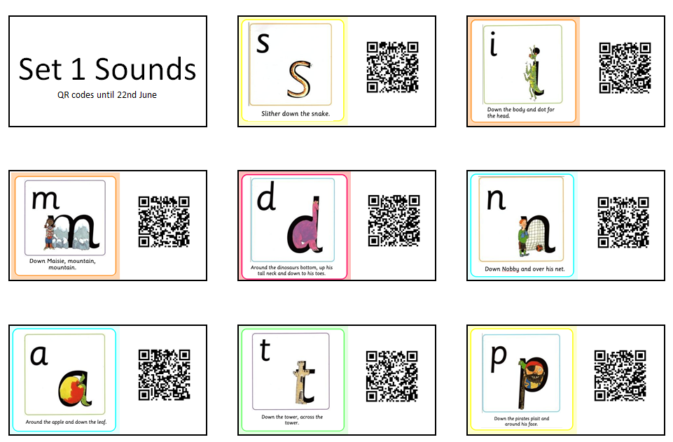

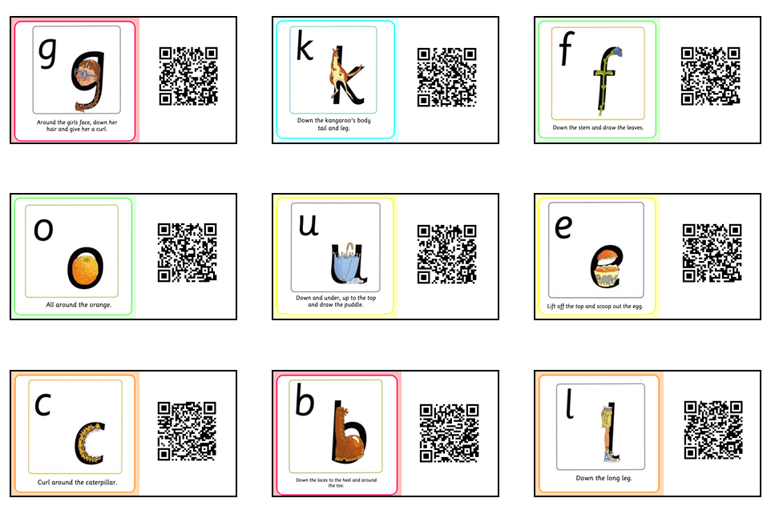

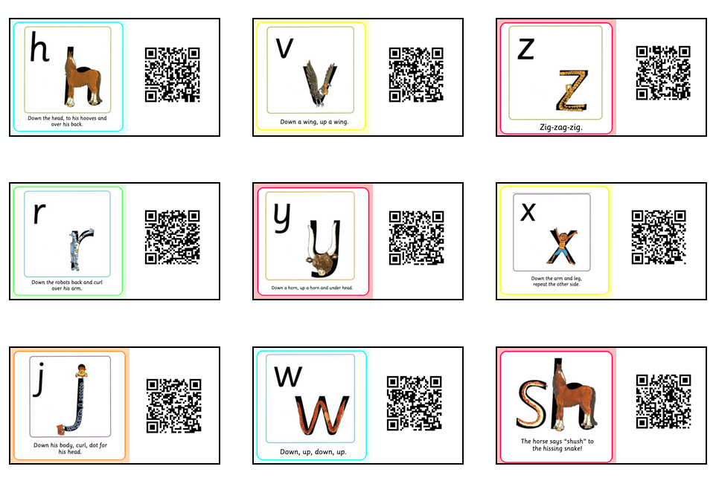
Once children have learnt all the single letter sounds – we move onto Special Friends (where two or more letters make one sound). Clips to the Set 1 Special Friends are below.
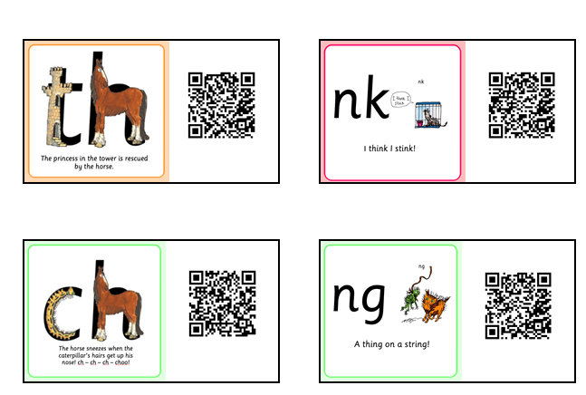

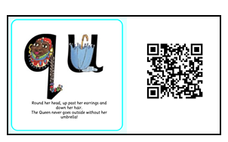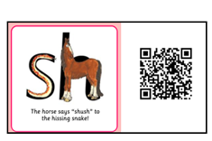
Children need to use their sound knowledge to read words with these sounds in them. They need to read words with two / three / four and five sounds and words with Special Friends.
We use the phrases
“Fred Talk” so that they sound out the word.
“Read the word” so that they put the sounds together to make the word.
The clips below will help with this.




For children in Group 1C



Wordtime 1.2






Wordtime 1.3




Wordtime 1.4







Wordtime 1.5

For Children in Ditty Group – film clips with word that have Special Friends
We use the phrases “Special Friends” to get them to identify any special friends in words.
Then “Fred Talk” so that they sound out the word.
“Read the word” so that they put the sounds together to make the word.






























All Children need to read RED words – these are words that we cannot decode. Below is the bookmark of RED words for Ditty/Red/Green and Purple Groups. These are words we just need to know by sight. The easiest way to learn them is to keep going over them until we can memorise them.
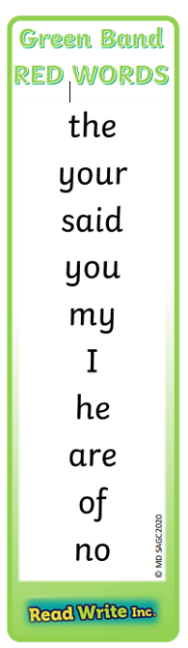
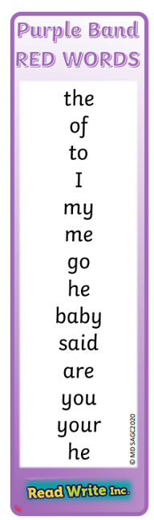
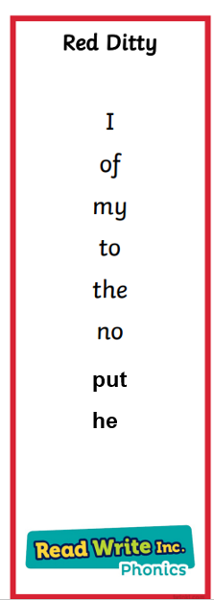

Speedy Reading
Children Need to be able to read words at speed. Below are the speedy reading grids for red and green groups. The children need to be able to read these words at a glance:
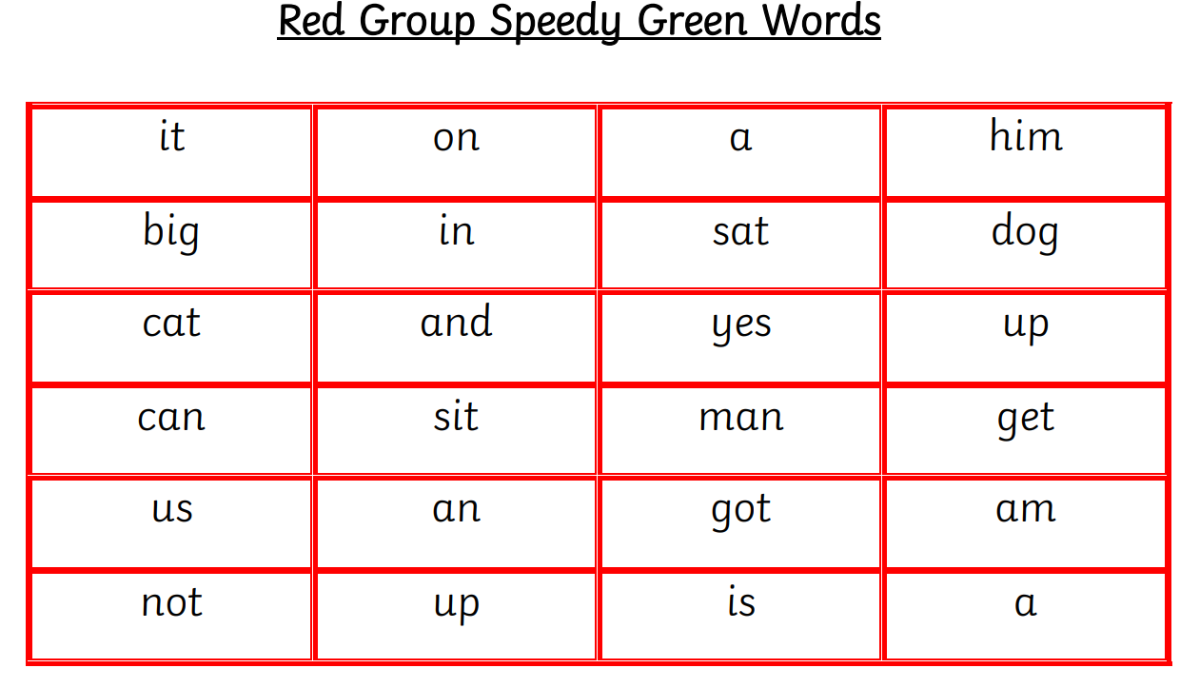
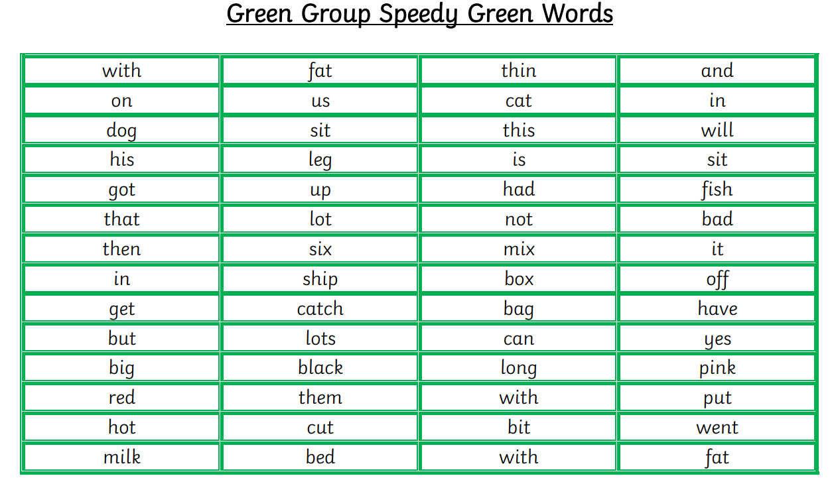

Once children are secure in Set 1 Sounds and reading words with Set 1 sounds and Set 1 Special Friends we move onto Set 2 sounds.
Below are short clips for each of these sounds.
