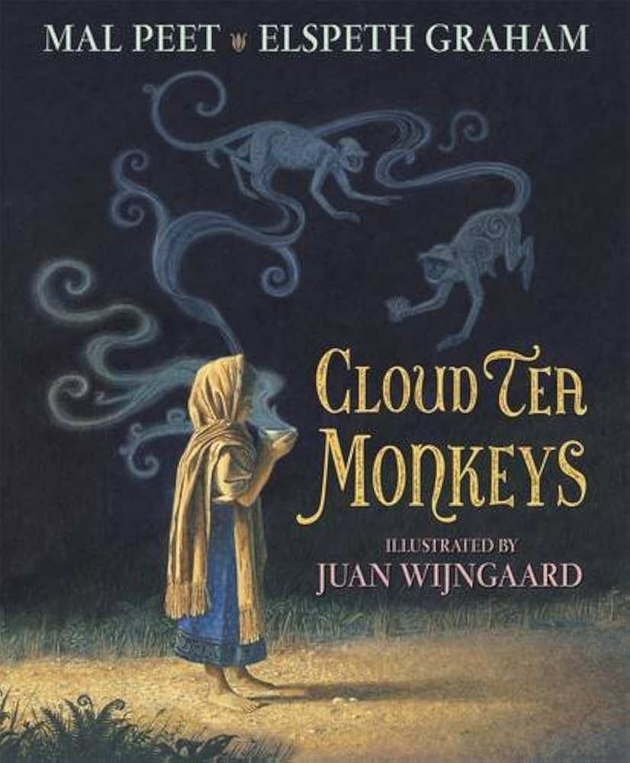
In this unit we will be learning to…
- write and use homophones
- ask questions for research
- use prepositions
- write in the present tense
- write a story non-chronological report

Non-chronological report

Handwriting

