

**DESIGN AND TECHNOLOGY CURRICULUM**

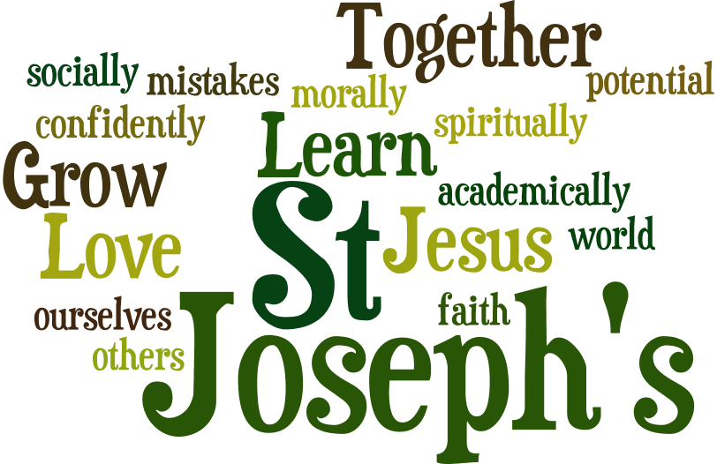

**LOVE LEARN GROW**



**ST JOSEPH’S CURRICULUM – Design and Technology**

**INTENT**

At St Joseph’s we believe that Design and Technology should be an important part of the curriculum. It allows children the opportunity to both think critically about problem solving in real world examples, and enhances the children’s understanding across other areas of the curriculum, for example Maths, Science, History and Geography.

We believe that children deserve the opportunity to use their creativity and imagination and that they should have exposure to a range of skills that will benefit them in their future lives.

* The curriculum has been mapped across the school to ensure that children are exposed to a range of different skills, and, that where skills are revisited, that there is real progression evident.
* A skills progression document is used to ensure children produce work that is ARE or greater with cross moderation taking place in each year group.
* When designing and making, the children are taught using the Design and Technology cycle:
* Analysis – look at already existing products to discuss their strengths and weaknesses.
* Design – using research to inform the design of innovative, functional, appealing products that are fit for purpose, aimed at particular individuals or groups
* Make – children are taught the skills and best practice using a range of tools and equipment (for example cutting, shaping, joining and finishing) accurately. They are also taught about a wider range of materials and components, including construction materials, textiles and ingredients, according to their functional properties and aesthetic qualities
* Evaluate- looking critically at their product - evaluate their ideas and products against their own design criteria and consider the views of others to improve their work.
* Work is recorded in the children’s sketch books so that children can use this as a growing bank of ideas of skills and designs.

**IMPLEMENTATION**

We ensure the children:

* Develop the creative, technical and practical expertise needed to perform everyday tasks confidently and to participate successfully in an increasingly technological world
* Build and apply a repertoire of knowledge, understanding and skills in order to design and make high-quality prototypes and products for a wide range of users and critique, evaluate and test their ideas and products and the work of others
* Understand and apply the principles of nutrition and learn how to cook. Children will design and make a range of products.

A good quality finish will be expected in all design and activities made appropriate to the age and ability of the child

Children learn how to take risks, becoming resourceful, innovative, enterprising and capable citizens. Through the evaluation of past and present design and technology, they develop a critical understanding of its impact on daily life and the wider world. High-quality design and technology education makes an essential contribution to the creativity, culture, wealth and well-being of the nation.

**IMPACT**

|  | DT CURRICULUM OVERVIEW | | | | | |
| --- | --- | --- | --- | --- | --- | --- |
| YEAR | ADVENT 1 | ADVENT 2 | LENT 1 | LENT 2 | PENTECOST 1 | PENTECOST 2 |
| Reception- as well as continuous provision these specific topics/projects are taught | Lets explore  Junk Modelling | Marvellous machines  Pushing and Pulling - make a bus | Long ago  Jam tarts |  |  | On the beach  Masks |
| Year 1 |  | Topic  Area of DT – Food  Final Product: Smoothies | **Topic:** **My family**  **Area of DT: Textiles**  **Final Product: Puppet**  Design and make a character-based hand puppet using a preferred joining technique, before decorating. |  |  | **Topic: Animal and Habitats**  **Area of DT: Structures**  Final Product: A Windmill  Inspired by the song, ‘Mouse in a windmill’, design and construct a windmill for a client (mouse) to live in. Explore various types of windmill, how they work and their key features. |
| Year 2 | **Topic:**  **Area of DT: Textiles**  **Final Product: Pouches**  Design and create a pouch using running stitch to join two sides. |  |  | **Topic: Holiday**  **Area of DT: Mechanism**  **Final Product: Ferris Wheel**  Design and create a functional Ferris wheel, learn how different components fit together so that the wheel rotates and the structure stands freely. | **Topic: Our wonderful world**  **Area of DT: Food**  **Final Product: Wrap**  The importance of a balanced diet and use that knowledge to create a tasty wrap. |  |
| Year 3 |  | **Topic**  **Area of DT: Mechanism**  **Final Product: Pneumatic toy** |  | Topic  **Area of DT: Digital World**  **Final Product: Design a piece of wearable tech using microbits/scratch.** |  | **Topic: Local History**  **Area of DT: Textile**  **Final Product: Cushion**  Learn and apply two new sewing techniques – cross-stitch and appliqué. Utilise these new skills to design and make a cushion |
| Year 4 |  | **Topic:**  **Area of DT: Frame Structures (pavilion planning Yr4)**  **Final Product: Pavillion**  Investigate and model frame structures to improve their stability, then apply this research to design and create a stable, decorated pavilion. |  | **Topic: Electricity – Science (revisit)**  **Area of DT: Electrical systems**  **Final Product: Torches**  Identify the difference between electrical and electronic products. Evaluate a range of existing torches and their features, then develop a new functional torch design. |  | **Topic: Food**  **Area of DT: Food**  **Final Product: Biscuits**  opportunities for children to learn a basic biscuits recipe and adapt it to suit a target audience. |
| Year 5 |  |  | **Topic: Space**  **Area of DT: Mechanisms**  **Final Product: Space pop up book**  Create a functional four-page pop-up storybook design, using lever, sliders, layers and spacers to create paper-based mechanisms. | **Topic: Mountains**  **Area of DT:**  **Digital World**  **Final Product: Monitoring devices**  Apply Computing knowledge and understanding to program a Micro: bit animal monitoring device. Develop 3D CAD skills by learning how to navigate the Tinkercad interface and essential tools to combine multiple objects. | **Topic: Journeys**  **Area of DT: Structures**  **Final Product: Bridges**  Test and analyse various types of bridge to determine their strength and stability. Explore material properties and sources, before marking, sawing and assembling a wooden truss bridge. |  |
| Year 6 | **Topic:**  **Area of DT: Electrical Systems**  **Final Product: Doodler** |  | **Topic:**  **Area of DT:** **Textiles.**  **Final Product:** **Stuffed Toy** | **Topic: Choices/ war food**  **Area of DT: Food**  **Final Product:**  **Come dine with me**  ‘Come dine with me’ project with learning about the basic tastes and complementary flavours. |  |  |

|  |  |  |
| --- | --- | --- |
| **EYFS – TOPIC/SKILLS AND KNOWLEDGE** | | |
| **EYFS** | **The Continuous Provision in EYFS means that DT is taught with a focus on continuous access and development of skills and knowledge, learnt through play.** | **Design**   * Begin to use the language of designing and making, e.g. join, build and shape. * Learning about planning and adapting initial ideas to make them better.   **Make**   * To learn to construct with a purpose in mind. * Selects tools and techniques needed to shape, assemble and join materials.   **Evaluate**   * Begin to talk about changes made during the making process, e.g. making a decision to use a different joining method.   **Technical Knowledge**   * To learn how to use a range of tools, e.g. scissors, hole punch, stapler, woodworking tools, rolling pins, pastry cutters. * Learn how everyday objects work by dismantling things   **Cooking and Nutrition**   * To begin to understand some of the tools, techniques and processes involved in food preparation. * Children have basic hygiene awareness. |