s



**ART CURRICULUM**

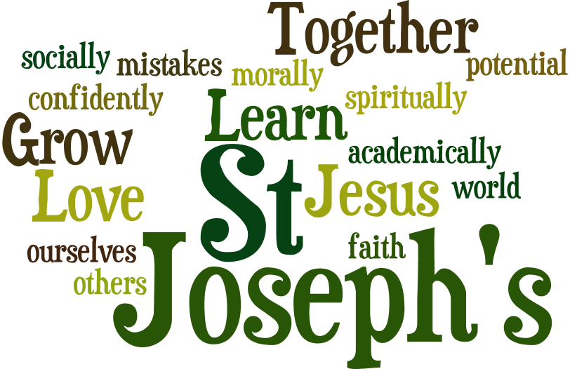

**LOVE LEARN GROW**



**ST JOSEPH’S CURRICULUM – ART**

**IMPACT**

Our art curriculum is high quality, well thought out and is planned to demonstrate progression.

Teaching staff are confident through knowledge and understanding to support children in expressing and experimenting with different art movements and forms.

Children feel confident in expressing and experimenting through art and can make links through the wider curriculum.

Children feel a sense of achievement when reflecting on their progression shown in their sketchbooks and different art forms produced.

Children are able to discuss, analyse, evaluate and show appreciation of the work of established artists, themselves and each other.

Assessment is an integral part of the process and will be carried out through constant reflection by each child and revisiting skills taught and work produced. Assessment will also be made by teaching staff through formative assessment to ensure progress of all children and summative assessments are made at the end of each term.

**IMPLEMENTATION**

At St Joseph’s school we believe high quality art lessons will: Inspire children to think innovatively and develop creative procedural understanding.

As children progress in their learning they should develop a more rigorous understanding of art and design.

Children should know how art and design both reflect and shape our history and contribute to the future and creativity around the world.

The art curriculum is intended to be delivered as a distinct subject with clear sequence of lesson incorporating clear vertical links throughout the school ensuring learning is deep and transferable year on year.

Through the study of specific artists and art forms, teaching staff will be able to make tangible links between art and the wider curriculum.

A broad range of artists are studied across the curriculum from a range of genders, social-economics background, nationality and races.

Teaching staff will endeavor to select artists who have not benefited from formal training to demonstrate that success in art is attainable for all.

Children are encouraged to take risks, experiment and then reflect on why some ideas and techniques are successful or not for a particular project.

Sketchbooks are used to record and develop and experiment with skills taught in years 1-6.

In lessons children are encouraged to be reflective and evaluate their work, thinking about how they can make changes and keep improving. Teaching staff ensure this is meaningful and continuous throughout the process, with evidence of age related verbal and written reflection.

**INTENT**

The art lead will provide all staff with information to support knowledge and skills ensuring all teaching staff feel supported and knowledgeable in delivering the art curriculum.

Children will be taught about key artists from a particular movement. They will explore the biographical detail of the artists and how this may have informed their work. Children will explore the movement of artists studied and explore where the movement is in art history time line, each year building on their knowledge and understanding of the history of art. Alongside the specific artists studied, children will have the opportunity to revisit previous years focus artist to review and reflect on prior knowledge and see how it links with their new focus.

To ensure progression within the subject - Children will be expected to mirror or recreate key works of art in EYFS, KS1 and lower KS2 with some artistic decision being made so it differs from the original. Pieces in Upper KS2 should be original pieces that utilise the features of a movement. Skills progression will be tracked throughout the school to ensure the artistic abilities reflect those of the national curriculum.

Vertical links are visible through repeated media and styles of painting. Portraits form the basis of artist study in year R, 2,4 and 6. Whilst landscapes are incorporated into artist study in year 1,3 and 5 Year groups alternate with the use of collage, textiles, and print.

Sketchbooks provide children with the opportunity to develop their skills and ideas. Teachers set a learning objective, children then have ownership on how they express and experiment using skills taught. Using peer assessment and discussion to support progression.

Teaching staff immerse children in the movement and art form studied by using writing across the curriculum and cross curricular planning.

A skills progression document will be used to ensure children produce work that is ARE or greater with cross moderation taking place in each year group.

| ART – TOPICS OVERVIEW | | | | | | |
| --- | --- | --- | --- | --- | --- | --- |
| YEAR | ADVENT 1 | ADVENT 2 | LENT 1 | LENT 2 | PENTECOST 1 | PENTECOST 2 |
| Reception- as well as continuous provision these specific topics/projects are taught. |  | Marvellous machine -  Outcome: Outside art Artist: Monet (Impressionism) |  | Ready, steady ,cook  Outcome: Colour mixing Artist: Kandinsky (Abstract) | Animal safari  Outcome: Collage Artist: ROA (Street Art) |  |
| Year 1 | Topic: People and Communities  Area of Art: Drawing & **Collage**  Outcome: Layered Collage  Artist: Van Gogh |  |  | Topic: Our local area  Area of Art: Drawing & **Digital media**  Outcome: Sunflower picture  Artist: Van Gough  (Post Impressionism) | Topic: Explorers (Captain Cook)  Area of Art: Drawing & **Textiles**  Outcome: Make an animal Home  Artist: David Hockney  (Modern Art) |  |
| Year 2 |  | Topic: Antarctic  Area of Art: Drawing & **Printing** Drawing/Printing/ screen  Outcome: Picture  Artist: Picasso  (Abstract) | Topic: Journeys/ food  Area of Art: Drawing & **3D**  Outcome: Texture art using clay  Artist: George Seurat  (Post Impressionism) |  |  | Topic: Superheroes  Area of Art: Drawing & **Painting**  Outcome: Painting  Artist: Andy Warhol  (Pop art) |
| Year 3 | Topic – Stone age  Area of Art – Drawing & **Painting**  Outcome: Painting  Artist: |  |  | Topic: Climate  Area of Art: Drawing & **Printing**  Outcome: Block Print  Artist: O’Keeffe  (Contemporary) | Topic: Our world  Area of Art: Drawing & **Digital Media**  Outcome: Digital Picture  Artist: Bernard Hoyes  (African American art) |  |
| Year 4 | Topic: Water  Area of Art: Drawing and **Collage**  Outcome: Water scene collage  Artist: Megan Coyle (Collage) |  | Topic: Romans  Area of Art: Drawing & **3D**  Outcome: Ceramic Mosaics  Artist: Emma Biggs  (Pop art) | Topic: The Americas  Area of Art: Drawing & **Textiles**  Outcome: Garment  Artist: Famous American fashion designers |  |  |
| Year 5 | Topic: Local environment  Area of Art: Drawing & **Sketching and Collage**  Outcome:  Henri Rousseau  (Post Impressionism): | Topic: Science / life cycles  Area of Art: Drawing & **Digital media**  Outcome:  Artist: Edward Wilson  ( scientific artist ) | Topic:  DT | Topic:  DT | Topic:  DT | Topic: Scientists  Area of Art: Drawing & **3D**  Outcome: Clay busts of scientists  Artist:  (Pre- Classical / Archaic) |
| Year 6 | Topic:  DT | Topic: Amazon  Area of Art: **Drawing**  Outcome: Animal sketch  Artist: Damien Hirst  (contemporary) | Topic:  DT | Topic:  DT | Area of Art: Drawing & **Painting**  Outcome:  Artist: Freida Kahlo  (Surrealism) | Topic: Light Camera Action  Area of Art: Drawing & **Printing**  Outcome: Block Printing  Artist: William Morris  (arts and crafts) |

|  |
| --- |
| **Art – RECEPTION**  **The Continuous Provision in EYFS means that Art is taught with a focus on continuous access and development of skills and knowledge, learnt through play.**  **Below are the links to the EYFS Framework that specifically support the development of knowledge and skills in Art although links can be found throughout the framework.** |
|  |

|  |  |  |  |
| --- | --- | --- | --- |
| Reception | Understanding the World | | * Talk about members of their immediate family and community * Name and describe people who are familiar to them. * Comment on images of familiar situations in the past. * Compare and contrast characters from stories, including figures from the past. * Understand that some places are special to members of their community. * Recognise that people have different beliefs and celebrate special times in different ways. * Recognise some similarities and differences between life in this country and life in other countries. * Explore the natural world around them. * Recognise some environments that are different from the one in which they live. |
| ELG | Understanding the World | Past and Present | * Talk about the lives of the people around them and their roles in society; * Know some similarities and differences between things in the past and now, drawing on their experiences and what has been read in class; * Understand the past through settings, characters and events encountered in books read in class and storytelling; |
| People, Cultures and Communities | * Describe their immediate environment using knowledge from observation, discussion, stories, non-fiction texts and maps; * Know some similarities and differences between different religious and cultural communities in this country, drawing on their experiences and what has been read in class; * Explain some similarities and differences between life in this country and life in other countries, drawing on knowledge from stories, non-fiction texts and – when appropriate – maps. |
|  |  |  |  |

|  |  |  |  |
| --- | --- | --- | --- |
| **Literacy** | | | |
| Reception | Communication and Language | | * Understand how to listen carefully and why listening is important. * Learn new vocabulary. * Use new vocabulary through the day * Ask questions to find out more and to check they understand what has been said to them * Articulate their ideas and thoughts in well-formed sentences. * Connect one idea or action to another using a range of connectives. * Describe events in some detail. * Use talk to help work out problems and organise thinking and activities, and to explain how things work and why they might happen. * Develop social phrases. * Engage in story times * Listen to and talk about stories to build familiarity and understanding. * Retell the story, once they have developed a deep familiarity with the text, some as exact repetition and some in their own words. * Use new vocabulary in different contexts. * Listen carefully to rhymes and songs, paying attention to how they sound. * Learn rhymes, poems and songs. * Engage in non-fiction books. * Listen to and talk about selected non-fiction to develop a deep familiarity with new knowledge and vocabulary. |
| ELG | Communication and language | Listening, Attention and Understanding | * Listen attentively and respond to what they hear with relevant questions, comments and actions when being read to and during whole class discussions and small group interactions; * Make comments about what they have heard and ask questions to clarify their understanding; * Hold conversation when engaged in back-and-forth exchanges with their teacher and peers. |
| Speaking | * Participate in small group, class and one-to-one discussions, offering their own ideas, using recently introduced vocabulary; * Offer explanations for why things might happen, making use of recently introduced vocabulary from stories, non-fiction, rhymes and poems when appropriate; * Express their ideas and feelings about their experiences using full sentences, including use of past, present and future tenses and making use of conjunctions, with modelling and support from their teacher. |